Chapter 17
Monopolistic Competition
MULTIPLE CHOICE
1. Monopolistic competition is characterized by which of the following attributes?
(i) free entry
(ii) product differentiation
(iii) many sellers
a. (i) and (iii) only
b. (i) and (ii) only
c. (ii) and (iii) only
d. (i), (ii), and (iii)
ANSWER: d. (i), (ii), and (iii)
TYPE: M DIFFICULTY: 1 SECTION: 17.1
2. The phenomenon of product differentiation contrasts sharply with the phenomenon of
a. homogeneous products.
b. industrial products.
c. monopolistic competition.
d. product integration.
ANSWER: a. homogeneous products.
TYPE: M DIFFICULTY: 1 SECTION: 17.1
3. In a monopolistically competitive industry, price is
a. equal to marginal cost since each firm is a price taker.
b. below marginal cost since each firm is a price taker.
c. above marginal cost since each firm is a price setter.
d. always a fraction of marginal cost since each firm is a price setter.
ANSWER: c. above marginal cost since each firm is a price setter.
TYPE: M DIFFICULTY: 2 SECTION: 17.1
4. In which of the following market structures is the number of sellers less than “many?”
(i) monopolistic competition
(ii) monopoly
(iii) oligopoly
a. (i) and (ii) only
b. (ii) and (iii) only
c. (ii) only
d. All of the above are correct.
ANSWER: b. (ii) and (iii) only
TYPE: M DIFFICULTY: 1 SECTION: 17.1
5. Which of the following market structures features free entry and exit?
(i) perfect competition
(ii) monopolistic competition
(iii) monopoly
a. (i) only
b. (i) and (ii) only
c. (ii) and (iii) only
d. All of the above are correct.
ANSWER: b. (i) and (ii) only
TYPE: M DIFFICULTY: 2 SECTION: 17.1
6. Monopolistic competition differs from perfect competition because in monopolistically competitive markets
a. there are barriers to entry.
b. all firms can eventually earn economic profits.
c. each of the sellers offers a somewhat different product.
d. strategic interactions between firms is vitally important.
ANSWER: c. each of the sellers offers a somewhat different product.
TYPE: M DIFFICULTY: 2 SECTION: 17.1
7. One way in which monopolistic competition differs from oligopoly is
a. there are no barriers to entry in oligopolies.
b. in oligopoly markets there are only a few sellers.
c. all oligopoly firms eventually earn zero economic profits.
d. strategic interactions between firms are rarely evident in oligopolies.
ANSWER: b. in oligopoly markets there are only a few sellers.
TYPE: M DIFFICULTY: 2 SECTION: 17.1
8. A similarity between monopoly and monopolistic competition is that, in both market structures,
a. strategic interactions among sellers are important.
b. there are fewer than “many” sellers.
c. sellers are price makers rather than price takers.
d. product differentiation is important.
ANSWER: c. sellers are price makers rather than price takers.
TYPE: M DIFFICULTY: 2 SECTION: 17.1
9. A profit-maximizing firm in a monopolistically competitive market differs from a firm in a perfectly competitive market because the firm in the monopolistically competitive market
a. is characterized by market share maximization.
b. has no barriers to entry.
c. faces a downward-sloping demand curve for its product.
d. faces a horizontal demand curve at the market clearing price.
ANSWER: c. faces a downward-sloping demand curve for its product.
TYPE: M DIFFICULTY: 2 SECTION: 17.1
10. The profit-maximizing rule for a firm in a monopolistically competitive market is to select the quantity at which
a. marginal revenue is equal to marginal cost.
b. average total cost is equal to marginal revenue.
c. average total cost is at its minimum value.
d. average revenue exceeds average total cost.
ANSWER: a. marginal revenue is equal to marginal cost.
TYPE: M DIFFICULTY: 2 SECTION: 17.1
11. A profit-maximizing firm in a monopolistically competitive market is characterized by which of the following?
a. Average revenue exceeds marginal revenue.
b. Marginal revenue exceeds average revenue.
c. Average revenue is equal to marginal revenue.
d. Revenue is always maximized along with profit.
ANSWER: a. Average revenue exceeds marginal revenue.
TYPE: M DIFFICULTY: 2 SECTION: 17.1

Use the figures below to answer questions 12 through 14.

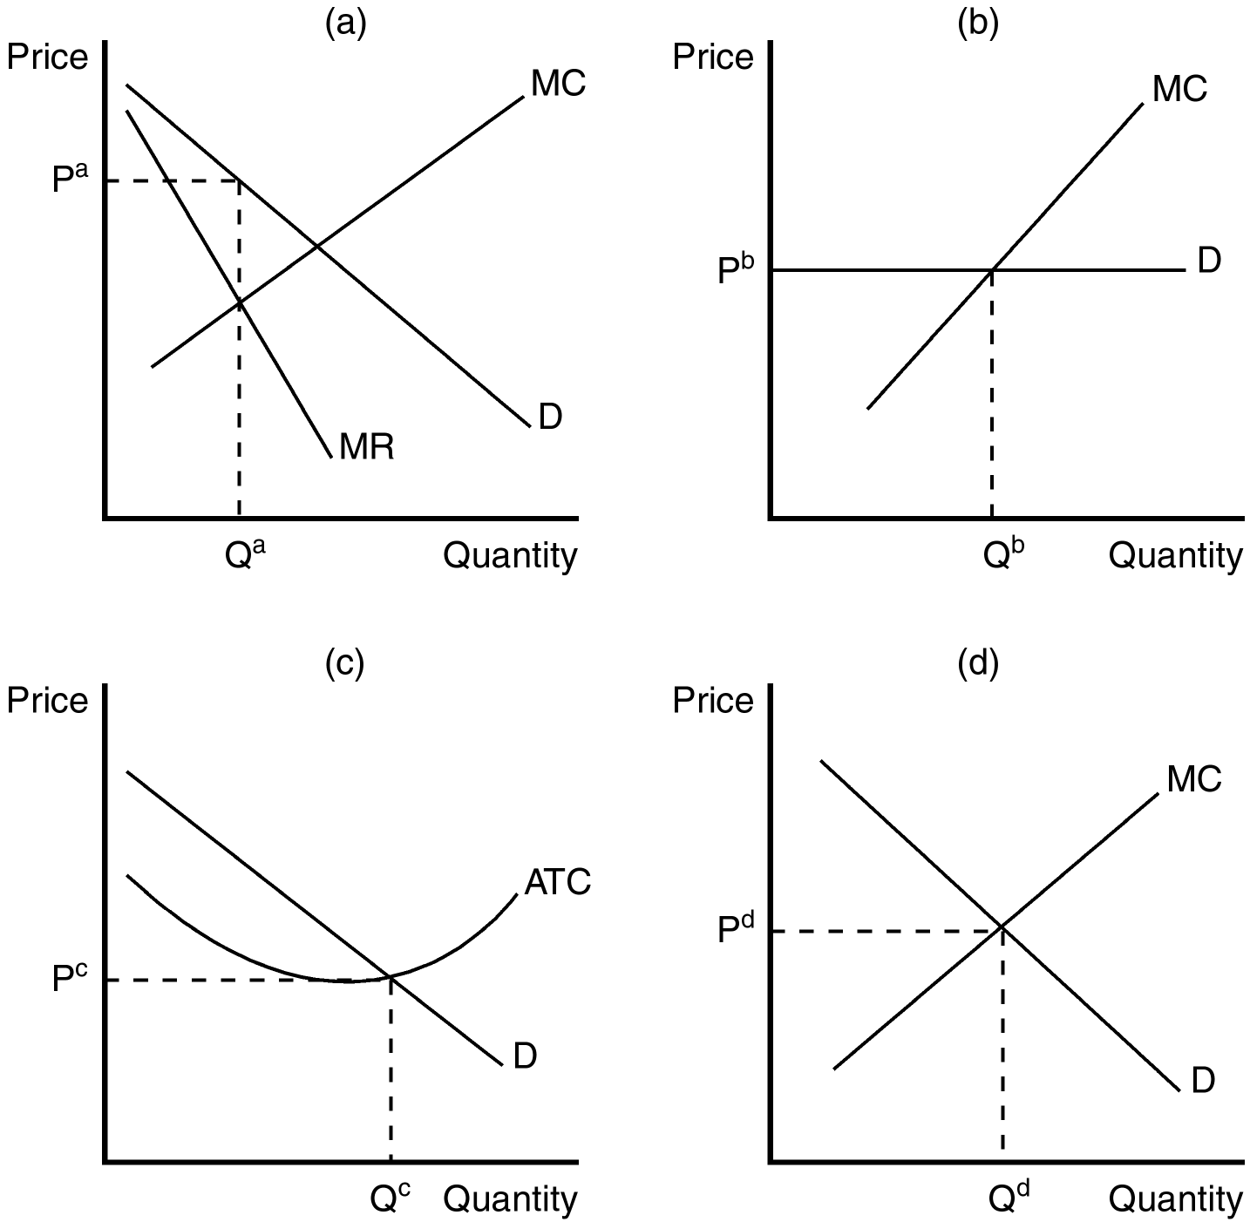

12. Which of the graphs would most likely represent a profit-maximizing firm in a monopolistically competitive market?
a. panel a
b. panel b
c. panel c
d. panel d
ANSWER: a. panel a
TYPE: M DIFFICULTY: 2 SECTION: 17.1
13. If a firm in a monopolistically competitive market was producing the level of output depicted as Qd in panel d, it would
a. not be maximizing its profit.
b. be minimizing its losses.
c. be losing market share to other firms in the market.
d. be operating at excess capacity.
ANSWER: a. not be maximizing its profit.
TYPE: M DIFFICULTY: 2 SECTION: 17.1
14. The firm depicted in panel b faces a horizontal demand curve. If panel b depicts a profit-maximizing firm,
a. it could be operating in either a perfectly competitive market or in a monopolistically competitive market.
b. it would not have excess capacity in its production as long as it is earning zero economic profit.
c. it is able to choose the price at which it sells its product.
d. All of the above are correct.
ANSWER: b. it would not have excess capacity in its production as long as it is earning zero economic profit.
TYPE: M DIFFICULTY: 2 SECTION: 17.1
15. Product differentiation causes the seller of a good to face what type of demand curve?
a. downward sloping
b. upward sloping
c. horizontal
d. vertical
ANSWER: a. downward sloping
TYPE: M DIFFICULTY: 2 SECTION: 17.1

Use the figure below to answer questions 16 through 18.

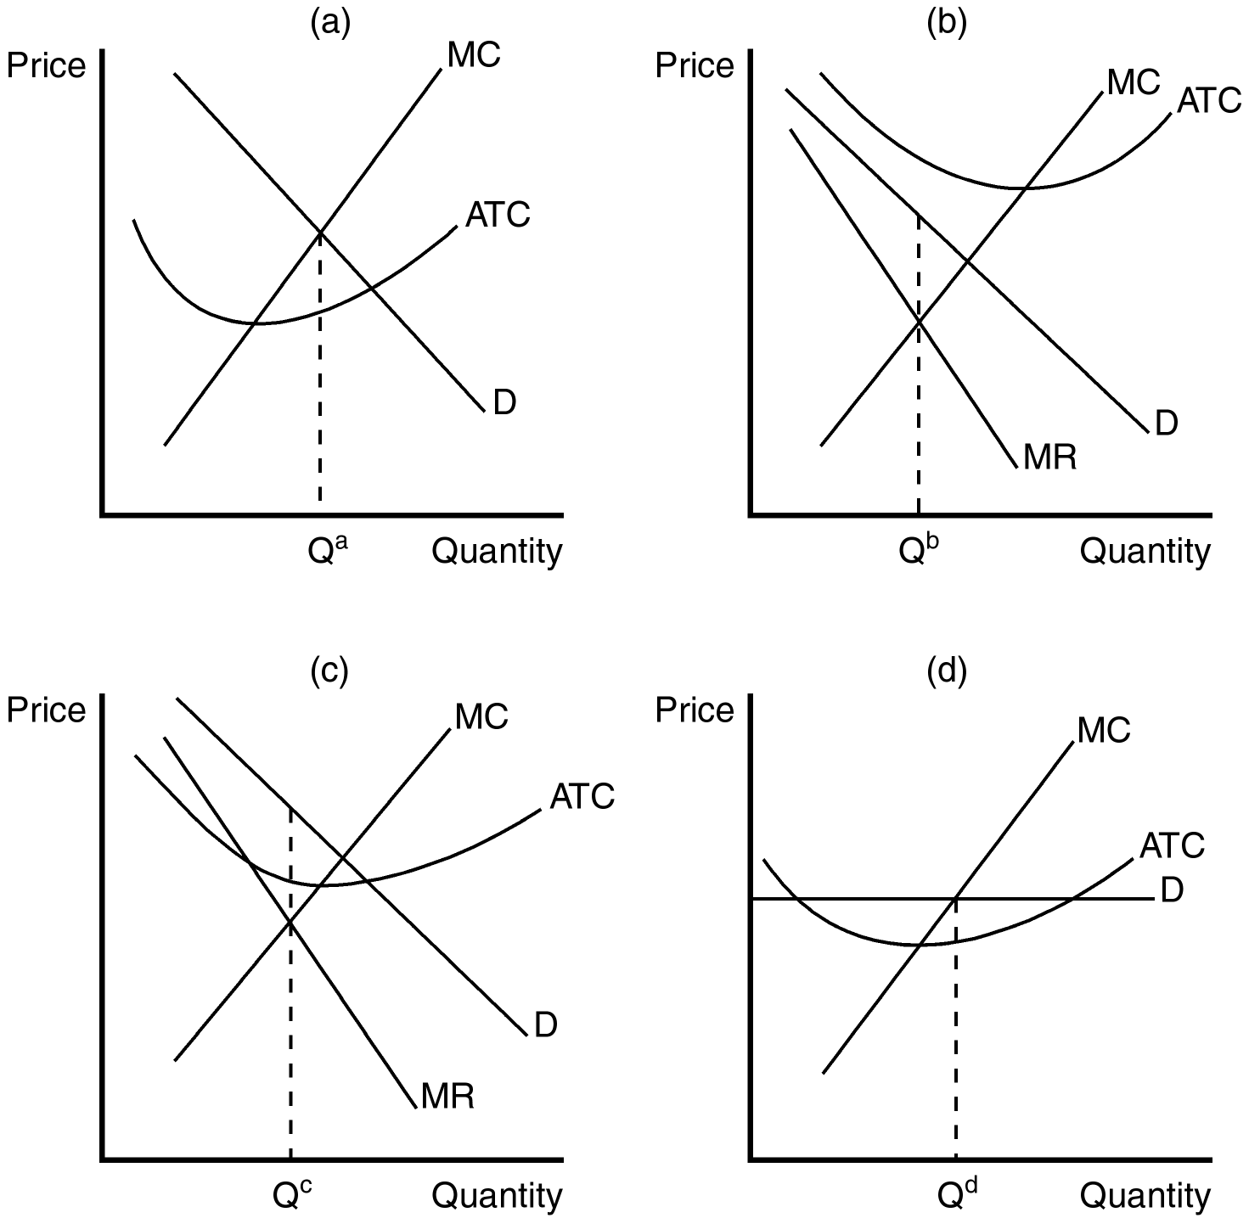

16. Which of the graphs shown would be consistent with a firm in a monopolistically competitive market that is earning a positive profit?
a. panel a
b. panel b
c. panel c
d. panel d
ANSWER: c. panel c
TYPE: M DIFFICULTY: 2 SECTION: 17.1
17. Which of the graphs shown would be consistent with a firm in a monopolistically competitive market that is doing its best but still losing money?
a. panel a
b. panel b
c. panel c
d. panel d
ANSWER: b. panel b
TYPE: M DIFFICULTY: 2 SECTION: 17.1
18. Which of the graphs depicts a monopolistically competitive firm in long-run equilibrium?
a. panel a
b. panel b
c. panel c
d. None of the above are correct.
ANSWER: d. None of the above are correct.
TYPE: M DIFFICULTY: 2 SECTION: 17.1
19. In the short run, a firm in a monopolistically competitive market operates much like a(n)
a. perfectly competitive firm.
b. oligopoly firm.
c. monopoly.
d. All of the above are correct.
ANSWER: c. monopoly.
TYPE: M DIFFICULTY: 2 SECTION: 17.1
20. A monopolistically competitive firm chooses
a. the quantity of output to produce, but the market determines price.
b. the price, but competition in the market determines the quantity.
c. price, but output is determined by a cartel production quota.
d. the quantity of output to produce and the price at which it will sell its output.
ANSWER: d. the quantity of output to produce and the price at which it will sell its output.
TYPE: M DIFFICULTY: 2 SECTION: 17.1
21. If firms in a monopolistically competitive market are earning positive profits,
a. firms will likely be subject to regulation.
b. barriers to entry will be strengthened.
c. some firms must exit the market.
d. new firms will enter the market.
ANSWER: d. new firms will enter the market.
TYPE: M DIFFICULTY: 2 SECTION: 17.1
22. If firms in a monopolistically competitive market are earning economic profits, which of the following scenarios would best reflect the change facing incumbent firms as the market adjusts to its new equilibrium?
a. an increase in demand
b. a decrease in demand
c. a downward shift in their marginal cost curve
d. an upward shift in their marginal cost curve
ANSWER: b. a decrease in demand
TYPE: M DIFFICULTY: 2 SECTION: 17.1
23. If firms in a monopolistically competitive market are incurring economic losses, which of the following scenarios would best reflect the change facing incumbent firms (who are able to stay in the market) as the market adjusts to its new equilibrium?
a. a downward shift in their marginal cost curve
b. an upward shift in their marginal cost curve
c. a decrease in demand
d. an increase in demand
ANSWER: d. an increase in demand
TYPE: M DIFFICULTY: 2 SECTION: 17.1

Lines in the figures below reflect the potential effect of entry and exit in a monopolistically competitive market on the demand and/or marginal cost curves of incumbent firms. Use these figures to answer questions 24 and 25.

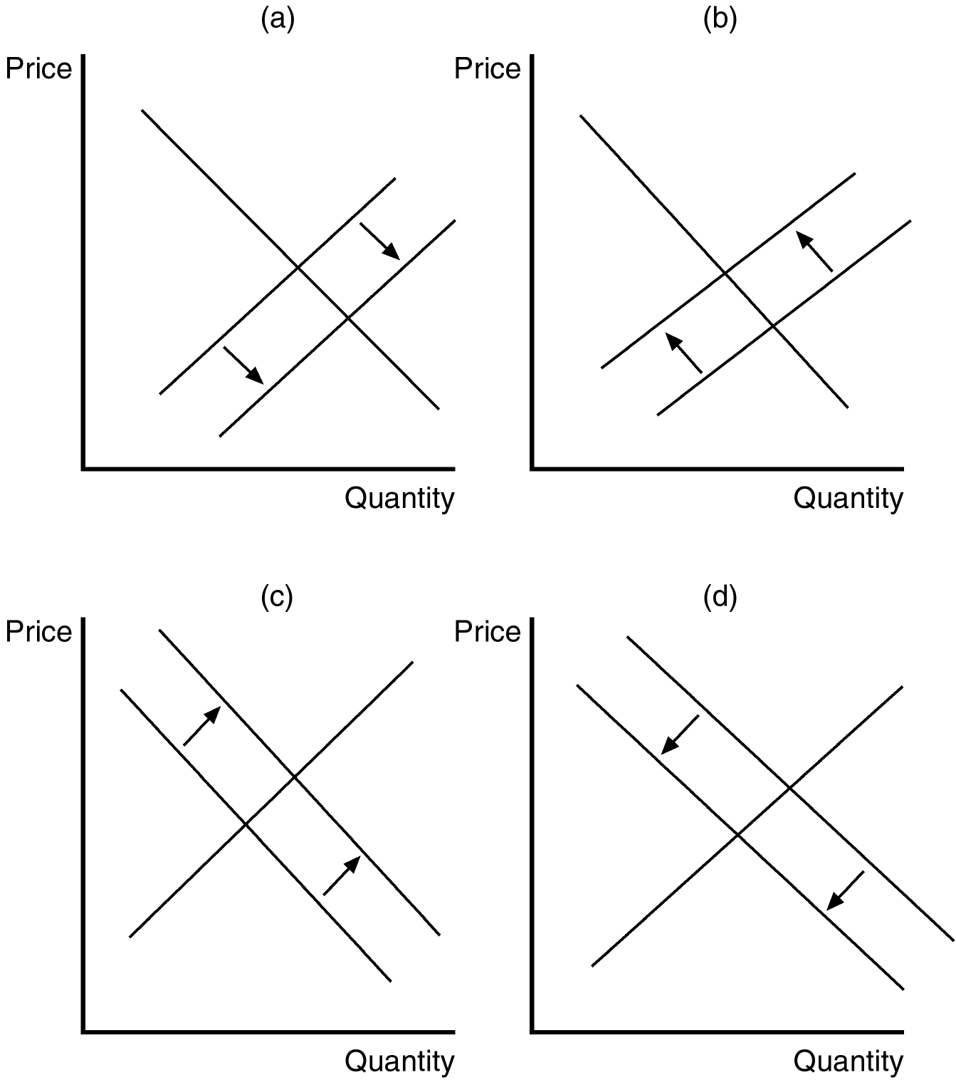

24. Panel d in the set of figures shown depicts the effect on incumbent firms of
a. long-run economic losses.
b. a decrease in the diversity of products offered in the market.
c. new entrants in the market.
d. existing firms exiting the market.
ANSWER: c. new entrants in the market.
TYPE: M DIFFICULTY: 2 SECTION: 17.1
25. Which of the diagrams depicts the effect on incumbent firms of some existing firms leaving the market?
a. panel a
b. panel b
c. panel c
d. panel d
ANSWER: c. panel c
TYPE: M DIFFICULTY: 2 SECTION: 17.1
26. In monopolistically competitive markets, economic profits
a. signal some incumbent firms to exit the market.
b. signal new firms to enter the market.
c. are maintained through government-imposed barriers to entry.
d. are never possible.
ANSWER: b. signal new firms to enter the market.
TYPE: M DIFFICULTY: 1 SECTION: 17.1
27. In monopolistically competitive markets, economic losses
a. signal some incumbent firms to exit the market.
b. signal new firms to enter the market.
c. are maintained through government-imposed barriers to exit.
d. are never possible.
ANSWER: a. signal some incumbent firms to exit the market.
TYPE: M DIFFICULTY: 1 SECTION: 17.1
28. As new firms enter a monopolistically competitive market, profits of existing firms
a. rise and product diversity in the market increases.
b. rise and product diversity in the market decreases.
c. decline and product diversity in the market increases.
d. decline and product diversity in the market decreases.
ANSWER: c. decline and product diversity in the market increases.
TYPE: M DIFFICULTY: 2 SECTION: 17.1
29. As some incumbent firms exit a monopolistically competitive market, profits of existing firms
a. decline and product diversity in the market decreases.
b. decline and product diversity in the market increases.
c. rise and product diversity in the market decreases.
d. rise and product diversity in the market increases.
ANSWER: c. rise and product diversity in the market decreases.
TYPE: M DIFFICULTY: 2 SECTION: 17.1
30. The free entry and exit of firms in a monopolistically competitive market guarantees that
a. both economic profits and economic losses can persist into the long run.
b. both economic profits and economic losses disappear in the long run.
c. economic profits can persist into the long run, but not economic losses.
d. economic losses can persist into the long run, but not economic profits.
ANSWER: b. both economic profits and economic losses disappear in the long run.
TYPE: M DIFFICULTY: 2 SECTION: 17.1
31. In monopolistically competitive markets, the property of free entry and exit suggests that
a. the market structure will eventually be characterized by perfect competition in the long run.
b. all firms earn zero economic profits in the long run.
c. some firms will be able to earn economic profits in the long run.
d. some firms will be forced to incur economic losses in the long run.
ANSWER: b. all firms earn zero economic profits in the long run.
TYPE: M DIFFICULTY: 2 SECTION: 17.1
32. When a profit-maximizing firm in a monopolistically competitive market is producing the long-run equilibrium quantity,
a. its average revenue will equal its marginal cost.
b. its marginal revenue will exceed its marginal cost.
c. it will be earning positive economic profits.
d. its demand curve will be tangent to its average-total-cost curve.
ANSWER: d. its demand curve will be tangent to its average-total-cost curve.
TYPE: M DIFFICULTY: 2 SECTION: 17.1
33. When a firm's demand (average revenue) curve is tangent to its average-total-cost curve, the
a. firm’s economic profit is zero.
b. firm must be earning economic profits.
c. firm must be incurring economic losses.
d. firm must be operating in a monopolistically competitive market.
ANSWER: a. firm’s economic profit is zero.
TYPE: M DIFFICULTY: 2 SECTION: 17.1

Use the figures below to answer questions 34 through 37

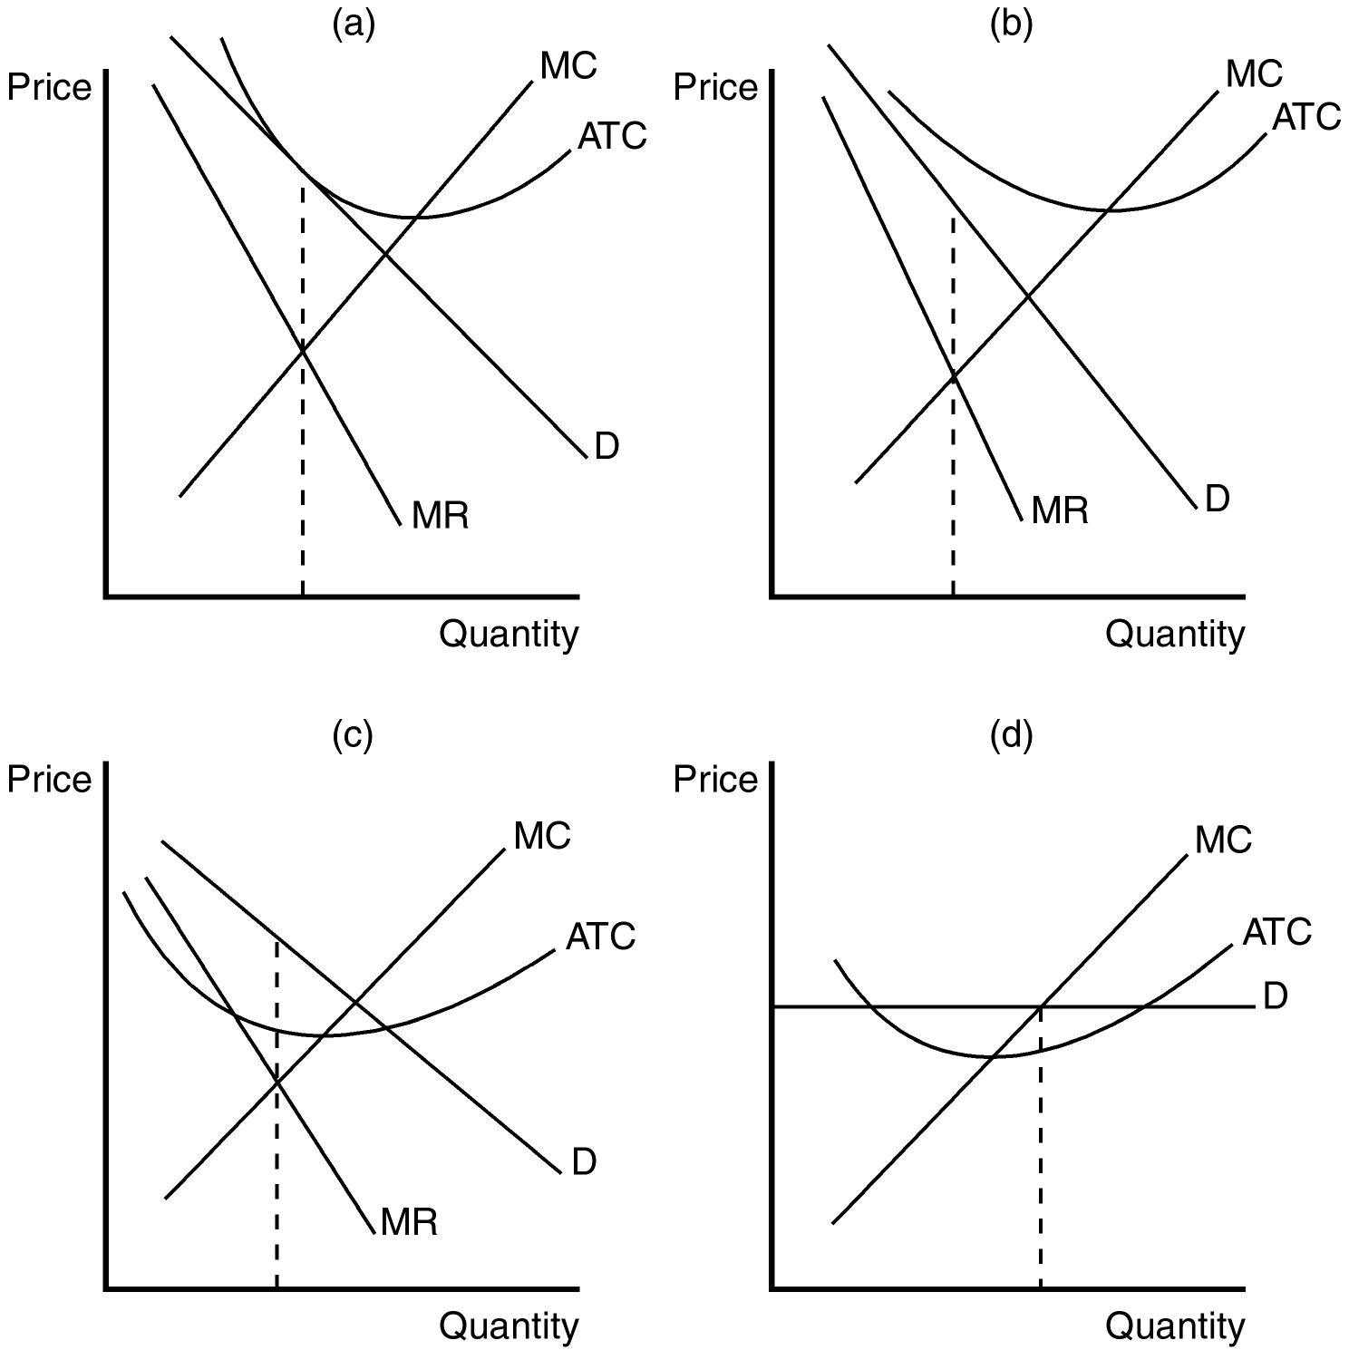

34. Panel (a) shows a profit-maximizing monopolistically competitive firm that is
a. earning a zero profit.
b. in long-run equilibrium.
c. charging a price that is equal to average total cost.
d. All of the above are correct.
ANSWER: d. All of the above are correct.
TYPE: M DIFFICULTY: 2 SECTION: 17.1
35. Which of the panels shown could characterize short-run equilibrium for a firm in a monopolistically competitive market?
a. panel a
b. panel b
c. panel c
d. All of the above are correct.
ANSWER: d. All of the above are correct.
TYPE: M DIFFICULTY: 2 SECTION: 17.1
36. Panel b in the set of figures shown is consistent with a firm in a monopolistically competitive market that is
a. in short-run equilibrium, but not long-run equilibrium.
b. in long-run equilibrium, but not short-run equilibrium.
c. in both short-run and long-run equilibrium.
d. earning a positive profit.
ANSWER: a. in short-run equilibrium, but not long-run equilibrium.
TYPE: M DIFFICULTY: 2 SECTION: 17.1
37. Which of the panels depicts a firm in a monopolistically competitive market earning economic profits?
a. panel c
b. panel d
c. both panels c and d
d. None of the above are correct.
ANSWER: a. panel c
TYPE: M DIFFICULTY: 2 SECTION: 17.1
38. When a profit-maximizing firm in a monopolistically competitive market is in long-run equilibrium,
a. the demand curve will be perfectly elastic.
b. price exceeds marginal cost.
c. marginal cost is falling.
d. marginal revenue exceeds marginal cost.
ANSWER: b. price exceeds marginal cost.
TYPE: M DIFFICULTY: 2 SECTION: 17.1
39. A profit-maximizing firm in a monopolistically competitive market always operates at the point of
a. minimum average total cost.
b. unitary elasticity of demand.
c. efficient scale.
d. None of the above are correct.
ANSWER: d. None of the above are correct.
TYPE: M DIFFICULTY: 2 SECTION: 17.1
40. Since a firm in a monopolistically competitive market faces a
a. downward-sloping demand curve, it will always operate with excess capacity.
b. downward-sloping demand curve, it will always operate at efficient scale.
c. perfectly elastic demand curve, it will always operate with excess capacity.
d. perfectly inelastic demand curve, it will always operate at efficient scale.
ANSWER: a. downward-sloping demand curve, it will always operate with excess capacity.
TYPE: M DIFFICULTY: 2 SECTION: 17.1
41. When a firm operates with excess capacity,
a. additional production would lower the average total cost.
b. additional production would increase average total cost.
c. it must be a perfectly competitive firm.
d. it must be a monopolistically competitive firm.
ANSWER: a. additional production would lower the average total cost.
TYPE: M DIFFICULTY: 2 SECTION: 17.1
42. When a firm operates at efficient scale,
a. its average revenue must exceed the minimum of average total cost.
b. its average revenue must be equal to the minimum of average total cost.
c. the average-total-cost curve must be falling.
d. the average-total-cost curve must be rising.
ANSWER: b. its average revenue must be equal to the minimum of average total cost.
TYPE: M DIFFICULTY: 3 SECTION: 17.1
43. In the long run, a firm in a perfectly competitive market operates at
a. efficient scale and a monopolistically competitive firm operates at efficient scale.
b. efficient scale and a monopolistically competitive firm operates with excess capacity.
c. excess capacity and a monopolistically competitive firm operates with excess capacity.
d. excess capacity and a monopolistically competitive firm operates at efficient scale.
ANSWER: b. efficient scale and a monopolistically competitive firm operates with excess capacity.
TYPE: M DIFFICULTY: 2 SECTION: 17.1
44. In the long run, a profit-maximizing firm in a monopolistically competitive market operates at
a. efficient scale.
b. a level of output at which average total cost is rising.
c. a level of output at which average total cost is falling.
d. the level of output at which total revenue is maximized.
ANSWER: c. a level of output at which average total cost is falling.
TYPE: M DIFFICULTY: 2 SECTION: 17.1
45. Product differentiation in monopolistically competitive markets ensures that, for profit-maximizing firms,
a. marginal revenue will equal average total cost.
b. price will exceed marginal cost.
c. marginal cost will exceed average revenue.
d. average variable cost will be declining.
ANSWER: b. price will exceed marginal cost.
TYPE: M DIFFICULTY: 2 SECTION: 17.1
46. A firm in a monopolistically competitive market operates
a. where marginal revenue is zero.
b. where marginal revenue is negative.
c. on the rising portion of its average-total-cost curve.
d. on the declining portion of its average-total-cost curve.
ANSWER: d. on the declining portion of its average-total-cost curve.
TYPE: M DIFFICULTY: 2 SECTION: 17.1
47. Hotels in New York City frequently experience an average vacancy rate of about 20 percent (i.e., on an average night, 80 percent of their rooms are full). This kind of excess capacity is indicative of what kind of market?
a. monopoly
b. perfect competition
c. monopolistic competition
d. oligopoly
ANSWER: c. monopolistic competition
TYPE: M DIFFICULTY: 2 SECTION: 17.1
48. For profit-maximizing firms in a monopolistically competitive market, another customer means
a. no change in profit.
b. more profit.
c. potential economic losses.
d. marginal cost could potentially exceed price.
ANSWER: b. more profit.
TYPE: M DIFFICULTY: 2 SECTION: 17.1
49. A profit-maximizing firm in a monopolistically competitive market is eager for another customer because
a. it wants to maintain the equality between price and marginal cost.
b. price exceeds marginal cost.
c. a markup over marginal cost is difficult to maintain.
d. it earns zero economic profits in the long run.
ANSWER: b. price exceeds marginal cost.
TYPE: M DIFFICULTY: 2 SECTION: 17.1
50. A monopolistically competitive market could be considered inefficient because
a. marginal revenue exceeds average revenue.
b. price exceeds marginal cost.
c. efficient scale is realized in the long run, but not in the short run.
d. markup pricing does not occur in any other market structure.
ANSWER: b. price exceeds marginal cost.
TYPE: M DIFFICULTY: 2 SECTION: 17.1
51. When a profit-maximizing firm in a monopolistically competitive market charges a price higher than marginal cost,
a. it is violating the antitrust laws.
b. it must be losing money.
c. there is a deadweight loss, but it is exactly offset by the benefit of excess capacity.
d. None of the above are correct.
ANSWER: d. None of the above are correct.
TYPE: M DIFFICULTY: 2 SECTION: 17.1
52. The deadweight loss that is associated with a monopolistically competitive market is a result of
a. price falling short of marginal cost in order to increase market share.
b. price exceeding marginal cost.
c. operating in a regulated industry.
d. excessive advertising costs.
ANSWER: b. price exceeding marginal cost.
TYPE: M DIFFICULTY: 2 SECTION: 17.1
53. Regulation of a firm in a monopolistically competitive market
a. usually implies a very small administrative burden.
b. will lower the firm’s costs.
c. is commonly used to enhance market efficiency.
d. is unlikely to improve market efficiency.
ANSWER: d. is unlikely to improve market efficiency.
TYPE: M DIFFICULTY: 2 SECTION: 17.1
54. The administrative burden of regulating price in a monopolistically competitive market is
a. small due to economies of scale.
b. large because price is usually below marginal cost.
c. large because of the large number of firms that produce differentiated products.
d. small because firms produce with excess capacity.
ANSWER: c. large because of the large number of firms that produce differentiated products.
TYPE: M DIFFICULTY: 2 SECTION: 17.1
55. If regulators required firms in monopolistically competitive markets to set price equal to marginal cost,
a. firms would most likely experience economic losses.
b. firms would also operate at maximum efficient scale.
c. new firms would be likely to enter the market.
d. the most efficient firms are not likely to be affected.
ANSWER: a. firms would most likely experience economic losses.
TYPE: M DIFFICULTY: 2 SECTION: 17.1
56. If regulators required firms in monopolistically competitive markets to set price equal to marginal cost,
a. firms would respond by lowering their costs.
b. firms would require a subsidy to stay in business
c. new firms that enter the market would operate at efficient scale.
d. the most efficient firms would not be affected.
ANSWER: b. firms would require a subsidy to stay in business
TYPE: M DIFFICULTY: 2 SECTION: 17.1
57. Inefficiency in monopolistically competitive markets can be identified with
a. inferior products produced by most firms.
b. government programs that effectively regulate price.
c. their similarities to perfectly competitive markets.
d. not having the "ideal" number of firms in the industry.
ANSWER: d. not having the "ideal" number of firms in the industry.
TYPE: M DIFFICULTY: 2 SECTION: 17.1
58. Before a new firm enters a monopolistically competitive market with a new product, it considers
a. the profit opportunities.
b. the business-stealing externality.
c. the product-variety externality.
d. All of the above are correct.
ANSWER: a. the profit opportunities.
TYPE: M DIFFICULTY: 2 SECTION: 17.1
59. The product-variety externality is associated with
a. the producer surplus that accrues to incumbent firms in a monopolistically competitive industry.
b. loss of consumer surplus from exposure to additional advertising.
c. the consumer surplus that is generated from the introduction of a new product.
d. the opportunity cost of firms exiting a monopolistically competitive industry.
ANSWER: c. the consumer surplus that is generated from the introduction of a new product.
TYPE: M DIFFICULTY: 2 SECTION: 17.1
60. When consumers are exposed to additional choices that result from the introduction of a new product,
a. their satisfaction is likely to be lowered as a result of their having to make additional choices.
b. a product-variety externality is said to occur.
c. an advertising externality is said to occur.
d. consumers are likely to experience negative consumption externalities.
ANSWER: b. a product-variety externality is said to occur.
TYPE: M DIFFICULTY: 2 SECTION: 17.1
61. A business-stealing externality
a. is likely to be punished under antitrust laws.
b. occurs when one firm attempts to duplicate exactly the product of a different firm.
c. is considered to be an explicit cost of business in monopolistically competitive markets.
d. is the negative externality associated with entry of new firms in a monopolistically competitive market.
ANSWER: d. is the negative externality associated with entry of new firms in a monopolistically competitive market.
TYPE: M DIFFICULTY: 2 SECTION: 17.1
62. When incumbent firms lose customers and profits due to entry of a new competitor, a
a. predatory pricing externality occurs.
b. consumption externality occurs.
c. business-stealing externality occurs.
d. product-variety externality occurs.
ANSWER: c. business-stealing externality occurs.
TYPE: M DIFFICULTY: 2 SECTION: 17.1
63. When the loss from a business-stealing externality exceeds the gain from a product-variety externality,
a. firms are more likely to operate at efficient scale.
b. there are likely to be too many firms in a monopolistically competitive market.
c. market efficiency is likely to be enhanced by the entry of new firms.
d. the market structure is likely to be in transition.
ANSWER: b. there are likely to be too many firms in a monopolistically competitive market.
TYPE: M DIFFICULTY: 2 SECTION: 17.1
64. The entry of new firms into a monopolistically competitive market is accompanied by
a. both positive and negative externalities.
b. only positive externalities.
c. only negative externalities.
d. only private profit opportunities (no externalities).
ANSWER: a. both positive and negative externalities.
TYPE: M DIFFICULTY: 2 SECTION: 17.1
65. The product-variety externality associated with monopolistic competition arises because in monopolistically competitive markets,
a. firms produce with excess capacity.
b. firms try to differentiate their products.
c. firms would like to produce homogeneous products, but the large number of firms prohibits it.
d. entry and exit is not restricted.
ANSWER: b. firms try to differentiate their products.
TYPE: M DIFFICULTY: 2 SECTION: 17.1

Use the following information for questions 66 and 67.

Vacation Inns of America (VIA) has recently announced intentions of building a new hotel/resort complex in Myrtle Beach, South Carolina. Assume that the hotel/resort market in Myrtle Beach is characterized by monopolistic competition.
66. As a result of the new VIA hotel/resort, tourists who stay in Myrtle Beach are likely to experience a
a. product-variety externality, which harms consumers.
b. product-variety externality, which benefits consumers.
c. business-stealing externality, which harms consumers.
d. business-stealing externality, which benefits consumers.
ANSWER: b. product-variety externality, which benefits consumers.
TYPE: M DIFFICULTY: 2 SECTION: 17.1
67. Existing hotels, motels, and lodging facilities in Myrtle Beach are likely to experience what kind of externality as a result of the new VIA hotel/resort?
a. product-variety
b. business-stealing
c. competitive
d. advertising
ANSWER: b. business-stealing
TYPE: M DIFFICULTY: 2 SECTION: 17.1
68. In a monopolistically competitive industry, firms’ demand curves also represent
a. marginal revenue.
b. marginal cost.
c. average revenue.
d. profit.
ANSWER: c. average revenue.
TYPE: M DIFFICULTY: 1 SECTION: 17.1
69. When a new firm enters a monopolistically competitive market, the individual demand curves faced by all existing firms in that market will
a. shift to the left.
b. shift to the right.
c. shift in a direction that is unpredictable without further information.
d. remain unchanged; only the supply curve will shift.
ANSWER: a. shift to the left.
TYPE: M DIFFICULTY: 2 SECTION: 17.1
70. When a firm exits a monopolistically competitive market, the individual demand curves faced by all existing firms in that market will
a. shift in a direction that is unpredictable without further information.
b. shift to the right.
c. shift to the left.
d. remain unchanged; only the supply curve will shift.
ANSWER: b. shift to the right.
TYPE: M DIFFICULTY: 2 SECTION: 17.1
71. Long-run profit earned by a monopolistically competitive firm is driven to the competitive level due to a
a. change in the technology that the firm utilizes.
b. shift of its demand curve.
c. shift of its supply curve.
d. None of the above are correct.
ANSWER: b. shift of its demand curve.
TYPE: M DIFFICULTY: 2 SECTION: 17.1
72. In the long run, a monopolistically competitive firm produces a quantity that is
a. equal to the efficient scale.
b. less than the efficient scale.
c. greater than the efficient scale.
d. consistent with diseconomies of scale.
ANSWER: b. less than the efficient scale.
TYPE: M DIFFICULTY: 2 SECTION: 17.1
73. Because a monopolistically competitive firm has some market power, in the long-run the price of its good exceeds its
a. average revenue.
b. average total cost.
c. marginal cost.
d. profit per unit.
ANSWER: c. marginal cost.
TYPE: M DIFFICULTY: 2 SECTION: 17.1
74. Which of the following markets impose deadweight losses on society?
(i) perfect competition
(ii) monopolistic competition
(iii) monopoly
a. (i) and (ii)
b. (ii) and (iii)
c. (i) and (iii)
d. (i) only
ANSWER: b. (ii) and (iii)
TYPE: M DIFFICULTY: 2 SECTION: 17.1
75. Which of the following goods are sold in a monopolistically competitive market?
a. compact discs
b. wheat
c. corn
d. postage stamps
ANSWER: a. compact discs
TYPE: M DIFFICULTY: 1 SECTION: 17.1
76. Which of the following goods are not sold in monopolistically competitive markets?
a. CDs
b. books
c. cookies
d. wheat
ANSWER: d. wheat
TYPE: M DIFFICULTY: 1 SECTION: 17.1
77. Monopolistically competitive markets differ from perfectly competitive markets because of
(i) the number of sellers.
(ii) barriers to entry.
(iii) product differentiation among the sellers.
a. (ii) only
b. (iii) only
c. (i) and (iii)
d. (ii) and (iii)
ANSWER: b. (iii) only
TYPE: M DIFFICULTY: 1 SECTION: 17.1
78. A firm in a monopolistically competitive market is similar to a monopoly in the sense that
(i) they both face downward-sloping demand curves.
(ii) they both charge a price that exceeds marginal cost.
(iii) both markets are characterized by free entry and exit.
a. (i) only
b. (ii) only
c. (i) and (ii)
d. (i) and (iii)
ANSWER: c. (i) and (ii)
TYPE: M DIFFICULTY: 2 SECTION: 17.1
79. A monopolistically competitive firm’s choice of output level is virtually identical to the choice made by a(n)
a. perfectly competitive firm.
b. duopolist.
c. monopolist.
d. oligopolist.
ANSWER: c. monopolist.
TYPE: M DIFFICULTY: 2 SECTION: 17.1
80. New firms will necessarily enter a monopolistically competitive market when price exceeds
a. marginal revenue.
b. average revenue.
c. marginal cost.
d. average total cost.
ANSWER: d. average total cost.
TYPE: M DIFFICULTY: 2 SECTION: 17.1
81. Which two curves are tangent to one another in a monopolistically competitive market with zero economic profit?
a. demand and average variable cost
b. demand and average total cost
c. marginal revenue and average variable cost
d. marginal revenue and average total cost
ANSWER: b. demand and average total cost
TYPE: M DIFFICULTY: 2 SECTION: 17.1
82. A downward-sloping demand curve
a. is a feature of all monopolistically competitive firms.
b. means that the firm in question will never experience a zero profit.
c. causes marginal revenue to exceed price.
d. All of the above are correct.
ANSWER: a. is a feature of all monopolistically competitive firms.
TYPE: M DIFFICULTY: 2 SECTION: 17.1
83. Excess capacity
a. tells economists little about the desirability of a market outcome.
b. is the primary source of market inefficiency in monopolistically competitive markets.
c. is a characteristic of rising average-total-cost curves.
d. is solely a characteristic of markup pricing.
ANSWER: a. tells economists little about the desirability of a market outcome.
TYPE: M DIFFICULTY: 2 SECTION: 17.1
84. In a monopolistically competitive market,
a. there are only a few sellers.
b. each firm takes the price of its product as given.
c. firms can enter or exit the market without restriction.
d. each firm produces a product that is essentially identical to the products of other firms in the market.
ANSWER: c. firms can enter or exit the market without restriction.
TYPE: M DIFFICULTY: 1 SECTION: 17.1
85. A monopolistically competitive market
a. has some features of monopoly and some features of competition.
b. has one large, dominant firm and many other smaller firms.
c. is very difficult to enter.
d. All of the above are correct.
ANSWER: a. has some features of monopoly and some features of competition.
TYPE: M DIFFICULTY: 1 SECTION: 17.1
86. In both perfect competition and monopolistic competition,
a. each firm is, in many ways, like a monopoly.
b. each firm sells a product that is at least slightly different from those of other firms.
c. each firm faces a downward-sloping demand curve.
d. there are many sellers.
ANSWER: d. there are many sellers.
TYPE: M DIFFICULTY: 1 SECTION: 17.1
87. Examples of monopolistically competitive markets include the markets for
a. restaurants and furniture.
b. books and movies.
c. cookies and restaurants.
d. All of the above are correct.
ANSWER: d. All of the above are correct.
TYPE: M DIFFICULTY: 1 SECTION: 17.1
88. Examples of monopolistically competitive markets do not include the market for
a. piano lessons.
b. soybeans.
c. cookies.
d. voice lessons.
ANSWER: b. soybeans.
TYPE: M DIFFICULTY: 1 SECTION: 17.1
89. For existing firms in a monopolistically competitive market,
a. strategic interactions among the firms are very important.
b. the threat of entry by new firms is not an important consideration.
c. the attainment of a Nash equilibrium is an important objective.
d. None of the above are correct.
ANSWER: d. None of the above are correct.
TYPE: M DIFFICULTY: 2 SECTION: 17.1
90. Each firm in a monopolistically competitive firm faces a downward-sloping demand curve because
a. there are many other sellers in the market.
b. there are very few other sellers in the market.
c. that firm’s product is different from those offered by other firms in the market.
d. that firm faces the threat of entry into the market by new firms.
ANSWER: c. that firm’s product is different from those offered by other firms in the market.
TYPE: M DIFFICULTY: 2 SECTION: 17.1
91. Both monopolistic competition and oligopoly are market structures
a. that lie between the extreme cases of competition and monopoly.
b. that feature only a few firms in each market.
c. to which the concept of Nash equilibrium is frequently applied by economists.
d. All of the above are correct.
ANSWER: a. that lie between the extreme cases of competition and monopoly.
TYPE: M DIFFICULTY: 2 SECTION: 17.1
92. When a market is monopolistically competitive, the typical firm in the market is likely to experience a
a. positive profit in the short run and in the long run.
b. positive or negative profit in the short run and a zero profit in the long run.
c. zero profit in the short run and a positive or negative profit in the long run.
d. zero profit in the short run and in the long run.
ANSWER: b. positive or negative profit in the short run and a zero profit in the long run.
TYPE: M DIFFICULTY: 2 SECTION: 17.1
93. Among the following situations, the one that is least likely to apply to a monopolistically competitive firm is that in which
a. profit is positive in the short run.
b. total cost exceeds total revenue in the short run.
c. profit is positive in the long run.
d. total revenue equals total cost in the long run.
ANSWER: c. profit is positive in the long run.
TYPE: M DIFFICULTY: 2 SECTION: 17.1
94. To maximize its profit, a monopolistically competitive firm
a. takes the price as given and it chooses its quantity, just as a competitive firm does.
b. takes the price as given and chooses its quantity, just as a colluding oligopolist does.
c. chooses its quantity and price, just as a competitive firm does.
d. chooses its quantity and price, just as a monopoly does.
ANSWER: d. chooses its quantity and price, just as a monopoly does.
TYPE: M DIFFICULTY: 2 SECTION: 17.1
95. To maximize its profit, a monopolistically competitive firm chooses its level of output by looking for the
a. intersection of the demand curve and the marginal cost curve.
b. intersection of the marginal revenue curve and the marginal cost curve.
c. level of output at which marginal revenue equals zero.
d. level of output at which average total cost is minimized.
ANSWER: b. intersection of the marginal revenue curve and the marginal cost curve.
TYPE: M DIFFICULTY: 2 SECTION: 17.1
96. When we compare diagrams for firms in different market structures, we see that
a. for competitive firms and monopolistically competitive firms, the revenue curves are similar but the cost curves are quite different.
b. for competitive firms and monopolistically competitive firms, the cost curves are similar but the revenue curves are quite different.
c. for monopoly firms and monopolistically competitive firms, the revenue curves are similar but the cost curves are quite different.
d. for monopoly firms and monopolistically competitive firms, the cost curves are similar but the revenue curves are quite different.
ANSWER: b. for competitive firms and monopolistically competitive firms, the cost curves are similar but the revenue curves are quite different.
TYPE: M DIFFICULTY: 1 SECTION: 17.1
97. For a monopolistically competitive firm,
a. marginal revenue and price are the same quantity.
b. average revenue and price are the same quantity.
c. at the profit-maximizing quantity of output, price equals marginal cost.
d. at the profit-maximizing quantity of output, marginal revenue exceeds price.
ANSWER: b. average revenue and price are the same quantity.
TYPE: M DIFFICULTY: 2 SECTION: 17.1
98. For a monopolistically competitive firm, at the profit-maximizing quantity of output,
a. price exceeds marginal revenue.
b. marginal revenue exceeds marginal cost.
c. marginal cost exceeds average revenue.
d. All of the above are correct.
ANSWER: a. price exceeds marginal revenue.
TYPE: M DIFFICULTY: 2 SECTION: 17.1
99. Ignoring oligopoly and focusing on the other three types of market structure, in which of those market structures does a profit-maximizing firm charge a price that exceeds marginal cost?
a. monopoly only
b. monopoly and monopolistic competition only
c. monopoly, monopolistic competition, and perfect competition
d. It depends on whether we are in the short run or the long run.
ANSWER: b. monopoly and monopolistic competition only
TYPE: M DIFFICULTY: 2 SECTION: 17.1
100. Ignoring oligopoly and focusing on the other three types of market structure, in which of those market structures does a profit-maximizing firm experience a zero economic profit?
a. perfect competition only
b. perfect competition and monopolistic competition only
c. perfect competition, monopolistic competition, and monopoly
d. It depends on whether we are in the short run or the long run.
ANSWER: d. It depends on whether we are in the short run or the long run.
TYPE: M DIFFICULTY: 2 SECTION: 17.1
101. An important difference between the situation faced by a profit-maximizing monopolistically competitive firm in the short run and the situation faced by that same firm in the long run is that in the short run,
a. price may exceed marginal revenue; in the long run, price equals marginal revenue.
b. price may exceed marginal cost; in the long run, price equals marginal cost.
c. price may exceed average total cost; in the long run, price equals average total cost.
d. there are many firms in the market; in the long run, there are only a few firms in the market.
ANSWER: c. price may exceed average total cost; in the long run, price equals average total cost.
TYPE: M DIFFICULTY: 2 SECTION: 17.1
102. Suppose that monopolistically competitive firms in a certain market are earning positive profits. In the transition from this initial situation to a long-run equilibrium,
a. the number of firms in the market decreases.
b. each incumbent firm experiences a decrease in demand for its product.
c. each incumbent firm experiences a rightward shift of its marginal revenue curve.
d. All of the above are correct.
ANSWER: b. each incumbent firm experiences a decrease in demand for its product.
TYPE: M DIFFICULTY: 2 SECTION: 17.1
103. Suppose that monopolistically competitive firms in a certain market are experiencing losses. In the transition from this initial situation to a long-run equilibrium,
a. the number of firms in the market decreases.
b. each incumbent firm experiences a decrease in demand for its product.
c. each firm experiences upward shifts of its marginal-cost and average-total-cost curves.
d. All of the above are correct.
ANSWER: a. the number of firms in the market decreases.
TYPE: M DIFFICULTY: 2 SECTION: 17.1
104. When a monopolistically competitive firm is in long-run equilibrium,
a. marginal revenue is equal to marginal cost.
b. marginal revenue is equal to average total cost.
c. marginal revenue is equal to price.
d. price is equal to marginal cost.
ANSWER: a. marginal revenue is equal to marginal cost.
TYPE: M DIFFICULTY: 2 SECTION: 17.1
105. When a monopolistically competitive firm is in long-run equilibrium,
a. price is equal to average total cost.
b. price exceeds marginal cost.
c. price exceeds marginal revenue.
d. All of the above are correct.
ANSWER: d. All of the above are correct.
TYPE: M DIFFICULTY: 2 SECTION: 17.1
106. Which of these types of firms can earn a positive economic profit in the long run?
a. monopolies, but not competitive firms or monopolistically competitive firms
b. monopolies and monopolistically competitive firms, but not competitive firms
c. monopolies, monopolistically competitive firms, and monopolies
d. None of the above are correct.
ANSWER: a. monopolies, but not competitive firms or monopolistically competitive firms
TYPE: M DIFFICULTY: 2 SECTION: 17.1
107. “In a long-run equilibrium, price is equal to average total cost.” This statement applies to
a. competitive markets, but not to monopolistically competitive markets or monopolies.
b. competitive and monopolistically competitive markets, but not to monopolies.
c. competitive and monopolistically competitive markets and to monopolies.
d. None of the above are correct.
ANSWER: b. competitive and monopolistically competitive markets, but not to monopolies.
TYPE: M DIFFICULTY: 2 SECTION: 17.1
108. For a profit-maximizing monopolistically competitive firm, price exceeds marginal cost
a. in the short run but not in the long run.
b. in the long run but not in the short run.
c. in both the short run and the long run.
d. in neither the short run nor the long run.
ANSWER: c. in both the short run and the long run.
TYPE: M DIFFICULTY: 2 SECTION: 17.1
109. Entry and exit drive each firm in a monopolistically competitive market to a point of tangency between its
a. marginal revenue curve and its total-cost curve
b. marginal revenue curve and its average-total-cost curve.
c. demand curve and its total-cost curve.
d. demand curve and its average-total-cost curve.
ANSWER: d. demand curve and its average-total-cost curve.
TYPE: M DIFFICULTY: 2 SECTION: 17.1
110. The point of tangency which characterizes long-run equilibrium for a monopolistically competitive firm always occurs at a certain level of output; call that level of output Q1. Then Q1
a. exceeds the level of output at which marginal revenue equals marginal cost.
b. exceeds the level of output at which marginal cost equals average total cost.
c. falls short of the level of output at which marginal revenue equals zero.
d. All of the above are correct.
ANSWER: c. falls short of the level of output at which marginal revenue equals zero.
TYPE: M DIFFICULTY: 3 SECTION: 17.1
111. For any firm, average total cost is minimized at a certain level of output; call that level of output Q1. For a monopolistically competitive firm in long-run equilibrium, Q1
a. is also the level of output at which marginal cost equals average total cost.
b. exceeds the level of output at which there is a point of tangency between the demand curve and the average-total-cost curve.
c. exceeds the level of output at which marginal revenue equals marginal cost.
d. All of the above are correct.
ANSWER: d. All of the above are correct.
TYPE: M DIFFICULTY: 3 SECTION: 17.1
112. In a situation of long-run equilibrium,
a. a perfectly competitive firm operates at its efficient scale.
b. a monopolistically competitive firm operates at its efficient scale.
c. neither a competitive firm nor a monopolistically competitive firm charges a markup over marginal cost.
d. All of the above are correct.
ANSWER: a. a perfectly competitive firm operates at its efficient scale.
TYPE: M DIFFICULTY: 2 SECTION: 17.1
113. In a situation of long-run equilibrium, the term
a. “excess capacity” applies to monopolistically competitive firms, but not to competitive firms.
b. “zero economic profit” applies to competitive firms, but not to monopolistically competitive firms.
c. “markup over marginal cost” applies to both monopolistically competitive and competitive firms.
d. All of the above are correct.
ANSWER: a. “excess capacity” applies to monopolistically competitive firms, but not to competitive firms.
TYPE: M DIFFICULTY: 2 SECTION: 17.1
114. Firm A is a perfectly competitive firm. Firm B is a monopolistically competitive firm. Both firms are currently maximizing their respective profits. Which of the following statements is correct?
a. Both Firm A and Firm B would be eager to make an additional sale.
b. Firm A would be eager to make an additional sale, but Firm B would not care whether it made an additional sale or not.
c. Firm B would be eager to make an additional sale, but Firm A would not care whether it made an additional sale or not.
d. Neither Firm A nor Firm B would care whether they made an additional sale or not.
ANSWER: c. Firm B would be eager to make an additional sale, but Firm A would not care whether it made an additional sale or not.
TYPE: M DIFFICULTY: 2 SECTION: 17.1
115. In a monopolistically competitive market,
a. the entry of new firms creates externalities.
b. the absence of restrictions on entry by new firms ensures that there will be no deadweight loss.
c. there are always too many firms in the market relative to the socially-optimal number of firms.
d. None of the above are correct.
ANSWER: a. the entry of new firms creates externalities.
TYPE: M DIFFICULTY: 2 SECTION: 17.1
116. Entry by new firms into a monopolistically competitive market
a. creates new consumer surplus.
b. imposes a positive externality on existing firms.
c. leads to the same externalities that are observed when new firms enter a perfectly competitive market.
d. All of the above are correct.
ANSWER: a. creates new consumer surplus.
TYPE: M DIFFICULTY: 3 SECTION: 17.1
117. A monopolistically competitive firm faces the following demand curve for its product:

Price ($) | 10 | 9 | 8 | 7 | 6 | 5 | 4 | 3 | 2 | 1
Quantity | 2 | 4 | 6 | 9 | 10 | 12 | 14 | 16 | 18 | 20

The firm has total fixed costs of $20 and a constant marginal cost of $2 per unit. The firm will
a. produce nine units; firms will enter the market in the long run.
b. produce 10 units; firms will enter the market in the long run.
c. produce 12 units; firms will enter the market in the long run.
d. produce 10 units; firms will exit the market in the long run.
ANSWER: a. produce nine units; firms will enter the market in the long run.
TYPE: M DIFFICULTY: 3 SECTION: 17.1
118. A monopolistically competitive firm faces the following demand curve for its product:

Price ($) | 10 | 9 | 8 | 7 | 6 | 5 | 4 | 3 | 2 | 1
Quantity | 2 | 4 | 6 | 8 | 10 | 12 | 14 | 16 | 18 | 20

The firm has total fixed costs of $20 and a constant marginal cost of $5 per unit. The firm will
a. produce two units; firms will exit the market in the long run.
b. produce four units; firms will exit the market in the long run.
c. produce six units; firms will exit the market in the long run.
d. produce eight units; firms will enter the market in the long run.
ANSWER: c. produce 6 units; firms will exit the market in the long run.
TYPE: M DIFFICULTY: 3 SECTION: 17.1
119. A monopolistically competitive firm faces the following demand curve for its product:

Price ($) | 10 | 9 | 8 | 7 | 6 | 5 | 4 | 3 | 2 | 1
Quantity | 2 | 4 | 6 | 8 | 10 | 12 | 14 | 16 | 18 | 20

The firm has total fixed costs of $40 and a constant marginal cost of $2 per unit. We can conclude that
a. firms will exit this market.
b. firms will enter this market.
c. this market is in long-run equilibrium.
d. this firm is operating at efficient scale.
ANSWER: c. this market is in long-run equilibrium.
TYPE: M DIFFICULTY: 3 SECTION: 17.1
120. A firm has the following cost structure:

Output | 1 | 2 | 3 | 4 | 5 | 6 | 7
Total Cost($) | 30 | 32 | 36 | 42 | 50 | 63 | 77

If this firm is in a typical monopolistically competitive market, it will likely produce
a. four or fewer units of output.
b. five units of output.
c. more than five units of output.
d. None of the above are correct; there is not enough information to tell.
ANSWER: a. 4 or fewer units of output.
TYPE: M DIFFICULTY: 3 SECTION: 17.1
121. A firm has the following cost structure:

Output | 1 | 2 | 3 | 4 | 5 | 6 | 7
Total Cost($) | 30 | 32 | 36 | 42 | 50 | 63 | 77

If this firm is in a typical perfectly competitive market, in the long run it will likely produce
a. 4 or fewer units of output.
b. 5 units of output.
c. more than 5 units of output.
d. there is not enough information to tell.
ANSWER: b. 5 units of output.
TYPE: M DIFFICULTY: 3 SECTION: 17.1
122. A monopolistically competitive firm has the following cost structure:

Output | 1 | 2 | 3 | 4 | 5 | 6 | 7
Total Cost($) | 30 | 32 | 36 | 42 | 50 | 63 | 77

The firm faces the following demand curve:

Price ($) | 20 | 18 | 15 | 12 | 9 | 7 | 4
Quantity | 1 | 2 | 3 | 4 | 5 | 6 | 7

To maximize profit (or minimize losses), the firm will produce
a. 2 units.
b. 3 units.
c. 4 units.
d. 5 units.
ANSWER: b. 3 units.
TYPE: M DIFFICULTY: 3 SECTION: 17.1
123. A monopolistically competitive firm has the following cost structure:

Output | 1 | 2 | 3 | 4 | 5 | 6 | 7
Total Cost($) | 30 | 32 | 36 | 42 | 50 | 63 | 77

The firm faces the following demand curve:

Price ($) | 20 | 18 | 15 | 12 | 9 | 7 | 4
Quantity | 1 | 2 | 3 | 4 | 5 | 6 | 7

If the government forces this firm to produce at its efficient scale, it will
a. produce 3 units and make $9.
b. produce 4 units and make $6
c. produce 5 units and lose $5.
d. produce 7 units and lose $49.
ANSWER: c. produce 5 units and lose $5.
TYPE: M DIFFICULTY: 3 SECTION: 17.1
124. A monopolistically competitive firm is currently making a profit. If other firms enter the market, we would expect that the added competition will cause this firm to adjust its
a. output so that it will operate closer to its efficient scale.
b. output so that it will operate further from its efficient scale.
c. output so that it will no longer be at its efficient scale.
d. output, but it might move either closer to or further from its efficient scale.
ANSWER: b. output so that it will operate further from its efficient scale.
TYPE: M DIFFICULTY: 3 SECTION: 17.1
125. Senator Hubris wants to pass a law that would require all monopolistically competitive firms to operate at their efficient scale. If this law were to pass and be enforced, we would expect that monopolistically competitive firms would
a. see their profits increase.
b. break even.
c. lose money.
d. not really be affected by the law.
ANSWER: c. lose money.
TYPE: M DIFFICULTY: 3 SECTION: 17.1
126. When firms sell highly differentiated consumer goods it is likely that one significant cost to all firms is
a. advertising.
b. fixed costs.
c. intermediate materials.
d. taxes and regulation.
ANSWER: a. advertising.
TYPE: M DIFFICULTY: 2 SECTION: 17.2
127. When advertising is deceptive, critics claim that it
a. increases competition in the market.
b. makes buyers less sensitive to price differences among similar products.
c. lowers the quality of goods in the market.
d. alters a firm's supply curve.
ANSWER: b. makes buyers less sensitive to price differences among similar products.
TYPE: M DIFFICULTY: 2 SECTION: 17.2
128. Critics claim that when advertising decreases the elasticity of demand, firms are able to
a. become more competitive.
b. increase their advertising budget.
c. lower their advertising budget.
d. charge a larger mark-up over marginal cost.
ANSWER: d. charge a larger mark-up over marginal cost.
TYPE: M DIFFICULTY: 2 SECTION: 17.2
129. When advertising is used to strengthen brand loyalty,
a. demand for the product becomes less elastic.
b. demand for related products is typically unaffected.
c. consumers become more sensitive to price differences among similar goods.
d. firms should lower price to increase revenue.
ANSWER: a. demand for the product becomes less elastic.
TYPE: M DIFFICULTY: 2 SECTION: 17.2
130. Advocates for advertising argue that the efficiency of markets is enhanced when advertising
a. focuses on issues other than the prices of products.
b. is psychological rather than informational.
c. decreases the elasticity of demand for a product.
d. provides information that is useful to consumers.
ANSWER: d. provides information that is useful to consumers.
TYPE: M DIFFICULTY: 2 SECTION: 17.2
131. Advertising that conveys information about the existence of new products
a. usually confuses consumers about market competition.
b. enhances the ability of markets to allocate resources efficiently.
c. reveals information that is of little value to consumers.
d. increases elasticity of demand.
ANSWER: b. enhances the ability of markets to allocate resources efficiently.
TYPE: M DIFFICULTY: 2 SECTION: 17.2
132. When advertising enhances the ability of markets to allocate resources, it is most likely to be
a. conveying information about price, the existence of new products or locations of retail outlets.
b. addressing psychological rather than informational characteristics of the good.
c. manipulating people's tastes.
d. increasing elasticity of supply.
ANSWER: a. conveying information about price, the existence of new products or locations of retail outlets.
TYPE: M DIFFICULTY: 2 SECTION: 17.2
133. When advertising encourages customers to become more informed about all firms in the market,
a. the demand for each particular brand in the market is likely to become less elastic.
b. firms are able to foster stronger brand loyalty.
c. each firm is likely to have less control over the price of its product.
d. the market power of individual firms is strengthened.
ANSWER: c. each firm is likely to have less control over the price of its product.
TYPE: M DIFFICULTY: 2 SECTION: 17.2
134. Advertising in markets for professional services (lawyers, doctors, etc.) has
a. decreased in recent years and competition in these markets has been enhanced.
b. decreased in recent years and competition in these markets has been reduced.
c. increased in recent years and competition in these markets has been enhanced.
d. increased in recent years and competition in these markets has been reduced.
ANSWER: c. increased in recent years and competition in these markets has been enhanced.
TYPE: M DIFFICULTY: 2 SECTION: 17.2
135. Professional organizations and producer groups have an incentive to
a. restrict advertising in order to enhance competition on the basis of price.
b. restrict advertising in order to reduce competition on the basis of price.
c. encourage advertising in order to reduce competition on the basis of price.
d. encourage advertising in order to enhance competition on the basis of price.
ANSWER: b. restrict advertising in order to reduce competition on the basis of price.
TYPE: M DIFFICULTY: 2 SECTION: 17.2
136. When firms in a monopolistically competitive market engage in price-related advertising, defenders of advertising argue that
a. the quality of products sold in the market always increases.
b. customers are less likely to be informed about other characteristics of the product.
c. new firms are discouraged from entering the market.
d. each firm has less market power.
ANSWER: d. each firm has less market power.
TYPE: M DIFFICULTY: 2 SECTION: 17.2
137. Critics of advertising argue that in some markets advertising may
a. attract products of lower quality into the market.
b. attract less informed buyers into the market.
c. decrease elasticity of demand.
d. enhance competition in markets to an unnecessary degree.
ANSWER: c. decrease elasticity of demand.
TYPE: M DIFFICULTY: 2 SECTION: 17.2
138. In the study done by Lee Benham on advertising for eyeglasses,
a. advertising increased the average price.
b. advertising decreased the average price.
c. there was no difference in price, but quality was better in the states that didn't allow advertising.
d. advertising appeared to have no effect whatsoever in the states that permitted advertising.
ANSWER: b. advertising decreased the average price.
TYPE: M DIFFICULTY: 1 SECTION: 17.2
139. Results of the study done by Lee Benham on advertising for eyeglasses would suggest that
a. brand loyalty and market power in the eyeglass market was likely to be more pervasive in states that allowed advertising.
b. eyeglass sales were more profitable in states that allowed advertising.
c. optometrists would not be supportive of advertising restrictions.
d. optometrists would enthusiastically endorse advertising restrictions.
ANSWER: d. optometrists would enthusiastically endorse advertising restrictions.
TYPE: M DIFFICULTY: 2 SECTION: 17.2
140. Advertising that uses celebrity endorsements is most likely intended to
a. increase elasticity of demand for the advertised product.
b. reduce the ability of markets to allocate resources efficiently.
c. provide a signal of product quality.
d. be useful only for psychological effects.
ANSWER: c. provide a signal of product quality.
TYPE: M DIFFICULTY: 2 SECTION: 17.2
141. Firms that spend a large amount of money on advertising a particular product are likely to be providing consumers with
a. information about the availability of the product.
b. information about product price.
c. a signal of product quality.
d. a good example of wasted resources.
ANSWER: c. a signal of product quality.
TYPE: M DIFFICULTY: 2 SECTION: 17.2
142. Defenders of advertising argue that it is not rational for profit-maximizing firms to spend money on advertising for products that have
a. superior quality.
b. inferior or mediocre quality.
c. low prices.
d. limited availability.
ANSWER: b. inferior or mediocre quality.
TYPE: M DIFFICULTY: 2 SECTION: 17.2
143. One theory of advertising suggests that
a. information on price is always a necessary ingredient of effective advertising.
b. the content of advertising may be irrelevant to product success in the market.
c. celebrity advertising is not effective in retail food markets.
d. Post and Kellogg should not advertise new cereals.
ANSWER: b. the content of advertising may be irrelevant to product success in the market.
TYPE: M DIFFICULTY: 2 SECTION: 17.2
144. Advertisements that appear to convey no information at all
a. are usually associated with "infomercials."
b. are mostly useless to consumers, but valuable to firms.
c. are mostly useless to firms, but valuable to consumers for their entertainment quality alone.
d. may convey information to consumers by providing them with a signal that firms are willing to spend significant amounts of money to advertise.
ANSWER: d. may convey information to consumers by providing them with a signal that firms are willing to spend significant amounts of money to advertise.
TYPE: M DIFFICULTY: 2 SECTION: 17.2
145. Critics of markets that are characterized by firms that sell "brand" name products argue that brand names encourage consumers to pay more for branded products that
a. have elastic demand curves.
b. are very different from generic products.
c. are indistinguishable from generic products.
d. consumer-advocate groups have found to be inferior.
ANSWER: c. are indistinguishable from generic products.
TYPE: M DIFFICULTY: 1 SECTION: 17.2
146. Edward Chamberlin argued that brand names
a. hampered market efficiency.
b. were instrumental in enhancing market efficiency.
c. were useful in enhancing market efficiency when the government enforced the use of exclusive trademarks.
d. were likely to be more socially efficient when used in conjunction with advertising.
ANSWER: a. hampered market efficiency.
TYPE: M DIFFICULTY: 1 SECTION: 17.2
147. The debate over the efficiency of markets in which products with brand names are sold
a. is framed by the role of regulation in advertising.
b. is likely to be resolved by reference to anecdotal evidence.
c. hinges on whether consumers are rational in their choices.
d. hinges on the effectiveness of advertising which identifies price differences.
ANSWER: c. hinges on whether consumers are rational in their choices.
TYPE: M DIFFICULTY: 2 SECTION: 17.2
148. A recent outbreak of hepatitis was linked to a national fast-food restaurant chain. This is an example of a case in which
a. brand name identity increases the effectiveness of markets.
b. brand name identity can be detrimental to the profitability of a firm.
c. advertising is ineffective in salvaging perceptions of product quality.
d. advertising cannot be used to establish brand loyalty.
ANSWER: b. brand name identity can be detrimental to the profitability of a firm.
TYPE: M DIFFICULTY: 1 SECTION: 17.2
149. Critics of vacation advertisements that depict "beautiful" human bodies on sun-drenched beaches as the primary focus of the message are likely to claim that the purpose of the advertisement is to
a. provide helpful information about a tourist destination.
b. manipulate people's tastes through psychological messages.
c. inflame carnal desire.
d. encourage sun-bathing in general.
ANSWER: b. manipulate people's tastes through psychological messages.
TYPE: M DIFFICULTY: 1 SECTION: 17.2
150. If advertising reduces a consumer's price sensitivity between identical goods, it is likely to
a. increase the elasticity of demand for differentiated products.
b. enhance competition, and encourage more product diversity.
c. impede competition and reduce social well-being.
d. encourage the consumption of all homogenous goods.
ANSWER: c. impede competition and reduce social well-being.
TYPE: M DIFFICULTY: 2 SECTION: 17.2
151. If a firm in a monopolistically competitive market successfully uses advertising to decrease elasticity of demand for its product,
a. the firm will be able to increase its markup over marginal cost.
b. the firm will eventually have to lower price to remain competitive.
c. it will increase the well-being of society.
d. it will reduce average total cost.
ANSWER: a. the firm will be able to increase its markup over marginal cost.
TYPE: M DIFFICULTY: 2 SECTION: 17.2
152. The primary claim of defenders of advertising is that it
a. conveys information about firm profitability.
b. is psychological rather than informational.
c. enhances the information available to consumers.
d. All of the above are correct.
ANSWER: c. enhances the information available to consumers.
TYPE: M DIFFICULTY: 1 SECTION: 17.2
153. Evidence suggests that, in markets with differentiated products but without a lot of advertising,
a. consumers are not confused by conflicting signals.
b. in general, firms are less profitable.
c. markets are less efficient.
d. consumers make better choices.
ANSWER: c. markets are less efficient.
TYPE: M DIFFICULTY: 2 SECTION: 17.2
154. Evidence suggests that, in markets with differentiated products and with a lot of advertising,
(i) consumers make better choices.
(ii) markets are less efficient.
(iii) in general, firms are less profitable.
a. (i) only
b. (iii) only
c. (ii) and (iii) only
d. All of the above are true.
ANSWER: a. (i) only
TYPE: M DIFFICULTY: 2 SECTION: 17.2
155. In markets where restrictions on advertising have been used to curtail competition, the U.S. courts have generally
a. referred the matters of advertising restrictions to executive regulators.
b. enforced industry-wide agreements to restrict advertising.
c. been silent on the effect of explicit advertising restrictions.
d. overturned laws that prohibit advertising.
ANSWER: d. overturned laws that prohibit advertising.
TYPE: M DIFFICULTY: 1 SECTION: 17.2
156. A law that restricts the ability of hotels/motels to advertise on billboards outside of a resort community would likely lead to
a. a decrease in profits for all hotels/motels.
b. reduced efficiency of local lodging markets.
c. a request by consumers to increase the number of billboards.
d. All of the above are correct.
ANSWER: b. reduced efficiency of local lodging markets.
TYPE: M DIFFICULTY: 2 SECTION: 17.2

Use the following information to answer questions 157 through 160.

Consider the problem facing two firms in the fast-food restaurant market, Firm A and Firm B. Each company has just come up with an idea for a new fast-food menu item, which it would sell for $4. Assume that the marginal cost for each new menu item is a constant $2 and the only fixed cost is for advertising. Each company knows that if it spends $12 million on advertising, it will get 2 million consumers to try its new product. Firm A has done market research which suggests that its product does not have any "staying" power in the market. Even though it could get 2 million consumers to buy the product once, it is unlikely that they will continue to buy the product in the future. Firm B's market research suggests that its product is very good, and consumers who try the product will continue to be consumers over the ensuing year. On the basis of its market research, Firm B estimates that its initial 2 million customers will buy one unit of the product each month in the coming year, for a total of 24 million units.
157. If Firm A decides to advertise its product it can expect to
a. get repeat sales above and beyond the initial 2 million consumers.
b. increase its market power.
c. incur a loss of $8 million.
d. have a profit of $4 million.
ANSWER: c. incur a loss of $8 million.
TYPE: M DIFFICULTY: 2 SECTION: 17.2
158. If firm B decides to advertise its product it can expect to
a. have a profit of $48 million per year.
b. have a profit of $36 million per year.
c. incur a loss of $12 million per year.
d. exit the industry.
ANSWER: b. have a profit of $36 million per year.
TYPE: M DIFFICULTY: 2 SECTION: 17.2
159. By its willingness to spend money on advertising, Firm B
a. signals the value of its new product to consumers.
b. signals that it is not a profit maximizer.
c. is detracting from the efficiency of markets.
d. None of the above are correct.
ANSWER: a. signals the value of its new product to consumers.
TYPE: M DIFFICULTY: 2 SECTION: 17.2
160. On the basis of a theory that people buy a product because it is advertised, the content of advertisements for Firm B's product
a. should focus on quality comparisons in order to be successful.
b should definitely include celebrity endorsements in order to be successful.
c. is critical to the success of the product in the market.
d. is irrelevant to the success of the advertisement.
ANSWER: d. is irrelevant to the success of the advertisement.
TYPE: M DIFFICULTY: 2 SECTION: 17.2
161. It is a well-publicized fact that television advertisements aired during major sporting events are very expensive. A theory asserting that people buy a product simply because it is advertised would suggest that information on the cost of advertising
a. enhances the effectiveness of the advertisement.
b. reduces people's willingness to purchase advertised products.
c. is leaked to discredit the firms that spend so much on advertising.
d. reduces the effective staying power of a product.
ANSWER: a. enhances the effectiveness of the advertisement.
TYPE: M DIFFICULTY: 2 SECTION: 17.2
162. In some countries, brand name fast-food restaurants are not allowed to operate. Such restrictions are likely to
a. enhance the social well-being of society.
b. enhance the choice set of consumers among local restaurants.
c. reduce barriers to entry in imperfect markets.
d. reduce the competitive nature of local fast-food markets.
ANSWER: d. reduce the competitive nature of local fast-food markets.
TYPE: M DIFFICULTY: 2 SECTION: 17.2
163. Eunice consumes Coke exclusively. She claims that there is a clear taste difference and that competing brands of cola leave an unsavory residual taste in her mouth. However, in a blind taste test, Eunice is found to prefer generic store-brand cola to Coke eight out of ten times. The results of Eunice's taste test would reinforce claims by critics of brand names that
a. consumers are always willing to pay more for brand names.
b. brand names cause consumers to perceive differences that do not really exist.
c. brand names cause consumers to be more sensitive to product differences.
d. brand names are a form of socially efficient advertising.
ANSWER: b. brand names cause consumers to perceive differences that do not really exist.
TYPE: M DIFFICULTY: 1 SECTION: 17.2
164. Your company has recently requested that you travel to Dhaka, Bangladesh, to work on negotiations for a new factory to be located in one of the port cities. Your travel agent provides a list of several hundred local hotels, and a Sheraton. In this case, the Sheraton brand-name is likely to be used as a signal of
a. perceived differences that are not likely to exist among your various options.
b. quality when quality cannot be easily judged.
c. inefficiency in markets characterized by recognizable brand names.
d. the quality of general lodging accommodations in Dhaka.
ANSWER: b. quality when quality cannot be easily judged.
TYPE: M DIFFICULTY: 1 SECTION: 17.2
165. During a recent visit to Miami, Florida, you stay in a “brand-name” hotel located in a deteriorating section of the inner city. You feel threatened by the location and are hesitant about leaving your hotel room during your stay. As a result of your experience, you vow never to stay with that particular hotel chain again. This example would reinforce the claim that
a. firms have a financial stake in maintaining the reputation of their brand names.
b. brand names are a signal of quality.
c. advertising is a waste of money for brand-name products.
d. None of the above are correct.
ANSWER: a. firms have a financial stake in maintaining the reputation of their brand names.
TYPE: M DIFFICULTY: 2 SECTION: 17.2
166. On a vacation to Cancun, Mexico, you find yourself eating every meal at the local McDonald's rather than having a hamburger from one of the street vendors. Your traveling companion claims that you are irrational, since you never eat McDonald's hamburgers when you are home and McDonald's hamburgers cost more than those prepared and sold by Cancun's street vendors. An economist would most likely explain your behavior by suggesting that
a. your behavior is rational, but your friend’s behavior is clearly irrational.
b. you are clearly irrational.
c. the McDonald's brand name guarantees consistent quality.
d. the advertising by McDonalds in Cancun is more persuasive than the advertising by McDonalds in your home town.
ANSWER: c. the McDonald's brand name guarantees consistent quality.
TYPE: M DIFFICULTY: 2 SECTION: 17.2
167. Which of the following is unique to a monopolistically competitive firm when compared to an oligopoly?
a. The monopolistically competitive firm advertises.
b. The monopolistically competitive firm produces a quantity of output that falls short of the socially optimal level.
c. Monopolistic competition features many buyers.
d. Monopolistic competition features many sellers.
ANSWER: d. Monopolistic competition features many sellers.
TYPE: M DIFFICULTY: 2 SECTION: 17.2
168. In dollar terms, the largest form of advertising in the United States is (are)
a. billboards.
b. newspaper and magazine ads.
c. radio ads.
d. television ads.
ANSWER: b. newspaper and magazine ads.
TYPE: M DIFFICULTY: 1 SECTION: 17.2
169. Firm A produces and sells in a market that is characterized by highly differentiated consumer goods. Firm B produces and sells industrial products. Firm C produces and sells an agricultural commodity. Which firm is likely to spend the greatest portion of its total revenue on advertising?
a. Firm A
b. Firm B
c. Firm C
d. There is no reason to believe that any one of the three firms would spend a greater portion of its total revenue on advertising than the other two firms.
ANSWER: a. Firm A
TYPE: M DIFFICULTY: 1 SECTION: 17.2
170. The fact that there is a great deal of advertising of men’s shaving products indicates that
a. the market for those products is perfectly competitive.
b. it costs firms very little to produce those products.
c. those products are highly differentiated.
d. All of the above are correct.
ANSWER: c. those products are highly differentiated.
TYPE: M DIFFICULTY: 2 SECTION: 17.2
171. In which of the following product markets are we likely to observe the largest amount of advertising?
a. markets in which price exceeds marginal cost
b. perfectly competitive markets
c. markets in which industrial products are sold
d. markets in which there is very little difference between different firms’ products
ANSWER: a. markets in which price exceeds marginal cost
TYPE: M DIFFICULTY: 2 SECTION: 17.2
172. Critics of advertising argue that advertising
a. creates desires that otherwise might not exist.
b. hinders competition.
c. often fails to convey substantive information.
d. All of the above are correct.
ANSWER: d. All of the above are correct.
TYPE: M DIFFICULTY: 1 SECTION: 17.2
173. Relative to other advertising expenditures, the largest number of dollars is spent on
a. television and radio commercials.
b. billboards and other signs.
c. space in magazines and newspapers.
d. direct mail.
ANSWER: c. space in magazines and newspapers.
TYPE: M DIFFICULTY: 1 SECTION: 17.2
174. A study of the market for optometrists’ services in the 1960s showed that
a. all states in the United States prohibited advertising by optometrists.
b. almost all professional optometrists opposed legal restrictions on their rights to advertise.
c. the average price of eyeglasses would be reduced by the removal of legal restrictions on advertising by optometrists.
d. All of the above are correct.
ANSWER: c. the average price of eyeglasses would be reduced by the removal of legal restrictions on advertising by optometrists.
TYPE: M DIFFICULTY: 2 SECTION: 17.2
175. Which of the following statements is correct? All theoretical arguments point to the fact that advertising leads to
a. higher prices and less competitive markets.
b. higher prices and more competitive markets.
c. lower prices and less competitive markets.
d. None of the above are correct; theoretical arguments fail to resolve the question of advertising’s effect on prices and competition.
ANSWER: d. None of the above are correct; theoretical arguments fail to resolve the question of advertising’s effect on prices and competition.
TYPE: M DIFFICULTY: 2 SECTION: 17.2
176. According to the “signaling theory” of advertising, consumers
a. pay little or no attention to which firms advertise and which firms do not advertise.
b. are often more impressed by a firm’s willingness to spend money on advertising than they are by the content of the advertisement.
c. are often more impressed by low-cost advertisements than they are by high-cost advertisements.
d. gain little or no information about product quality from advertisements.
ANSWER: b. are often more impressed by a firm’s willingness to spend money on advertising than they are by the content of the advertisement.
TYPE: M DIFFICULTY: 2 SECTION: 17.2
177. ABC Company knows that it produces and sells a very good mouse trap. XYZ Company knows that it produces and sells a lousy mouse trap. According to the “signaling theory” of advertising, the quality difference likely produces the result that
a. both ABC and XYZ have incentives to spend large amounts of money on advertising their mouse traps.
b. ABC has an incentive to spend a large amount of money on advertising its mouse trap, but XYZ does not.
c. XYZ has an incentive to spend a large amount of money on advertising its mouse trap, but ABC does not.
d. neither ABC nor XYZ has an incentive to spend a large amount of money on advertising their mouse traps.
ANSWER: c. XYZ has an incentive to spend a large amount of money on advertising its mouse trap, but ABC does not.
TYPE: M DIFFICULTY: 2 SECTION: 17.2
178. Two soft drinks sit side-by-side in a grocery store: A six-pack of Coca-Cola (a brand name) sells for $3.00, while a six-pack of Uncle Don’s cola (not a brand name) sells for $1.50. Even defenders of brand names would have to admit that
a. no rational consumer would spend twice as much for Coca-Cola as he would for Uncle Don’s cola.
b. the side-by-side presence of these two colas conveys no useful information to consumers.
c. Coca-Cola has no incentive to maintain the quality of its product just because of the Coca-Cola brand name.
d. None of the above are correct.
ANSWER: d. None of the above are correct.
TYPE: M DIFFICULTY: 2 SECTION: 17.2
179. Which of the following statements is false?
a. The typical monopolistically competitive firm could reduce its average total cost if it produced more output.
b. Monopolistically competitive firms advertise in order to increase the elasticity of the demand curve they face.
c. Expensive advertising might help consumers if it is a signal that the product is good.
d. Brand names acquired at great cost might help consumers by assuring quality.
ANSWER: b. Monopolistically competitive firms advertise in order to increase the elasticity of the demand curve they face.
TYPE: M DIFFICULTY: 2 SECTION: 17.2
TRUE/FALSE
1. For a profit-maximizing firm in a monopolistically competitive market, when price is equal to average total cost, price must lie above marginal cost.
ANSWER: T TYPE: TF DIFFICULTY: 2 SECTION: 17.1
2. Product differentiation always leads to some measure of market power.
ANSWER: T TYPE: TF DIFFICULTY: 2 SECTION: 17.1
3. A monopolistically competitive market is characterized by barriers to entry.
ANSWER: F TYPE: TF DIFFICULTY: 1 SECTION: 17.1
4. A profit-maximizing firm in a monopolistically competitive market always prices its product at some markup over marginal cost.
ANSWER: T TYPE: TF DIFFICULTY: 2 SECTION: 17.1
5. Monopolistic competition is the only market structure that features “many sellers.”
ANSWER: F TYPE: TF DIFFICULTY: 1 SECTION: 17.1
6. Excess capacity characterizes firms in monopolistically competitive markets, even in situations of long-run equilibrium.
ANSWER: T TYPE: TF DIFFICULTY: 2 SECTION: 17.1
7. When a firm operates at excess capacity, it must be in a monopolistically competitive market.
ANSWER: F TYPE: TF DIFFICULTY: 2 SECTION: 17.1
8. When a firm operates at efficient scale, it is producing at the minimum point on its average-total-cost curve.
ANSWER: T TYPE: TF DIFFICULTY: 1 SECTION: 17.1
9. A firm that would experience higher average total cost by increasing production is operating with excess capacity.
ANSWER: F TYPE: TF DIFFICULTY: 2 SECTION: 17.1
10. A profit-maximizing firm in a monopolistically competitive market always operates on the downward-sloping portion of its marginal cost curve.
ANSWER: F TYPE: TF DIFFICULTY: 2 SECTION: 17.1
11. A price markup over marginal cost is inconsistent with market attributes of free entry and zero profit.
ANSWER: F TYPE: TF DIFFICULTY: 2 SECTION: 17.1
12. When a firm in a monopolistically competitive market earns zero economic profit, its product price must equal marginal cost.
ANSWER: F TYPE: TF DIFFICULTY: 2 SECTION: 17.1
13. When a profit-maximizing firm in a monopolistically competitive market is in long-run equilibrium, marginal cost must lie below average total cost.
ANSWER: T TYPE: TF DIFFICULTY: 2 SECTION: 17.1
14. A firm in a monopolistically competitive market is usually indifferent to an additional customer walking through the door, since a sale to that customer will not increase the firm’s profit.
ANSWER: F TYPE: TF DIFFICULTY: 2 SECTION: 17.1
15. When advertising is used to relay information about price, each firm is able to enhance market power.
ANSWER: F TYPE: TF DIFFICULTY: 2 SECTION: 17.2
16. Policymakers have generally come to accept the view that advertising enhances the efficiency of markets.
ANSWER: T TYPE: TF DIFFICULTY: 2 SECTION: 17.2
17. Critics of advertising that focuses on product characteristics argue that it leads to less elastic demand for products.
ANSWER: F TYPE: TF DIFFICULTY: 2 SECTION: 17.2
18. Economists who argue that advertising enhances market efficiency suggest that celebrity advertising signals inferior product quality.
ANSWER: F TYPE: TF DIFFICULTY: 2 SECTION: 17.2
19. When McDonalds opens a store in Dhaka, Bangladesh, it has a strong incentive to enforce product quality consistent with stores in the United States.
ANSWER: T TYPE: TF DIFFICULTY: 2 SECTION: 17.2
20. The Mikati Philippines Hard Rock Cafe has the exact same menu as the Hard Rock Cafe in New York. This is an example of a brand name enhancing market efficiency for U.S. tourists visiting the Philippines.
ANSWER: T TYPE: TF DIFFICULTY: 2 SECTION: 17.2
21. Empirical evidence suggests that advertising usually leads to an increase in the price for advertised products.
ANSWER: F TYPE: TF DIFFICULTY: 2 SECTION: 17.2
22. Advertising during the Super Bowl is an example of information about quality contained primarily in the existence and expense of the advertising.
ANSWER: T TYPE: TF DIFFICULTY: 2 SECTION: 17.2
23. Brand names are rarely used to convey information about product quality.
ANSWER: F TYPE: TF DIFFICULTY: 2 SECTION: 17.2
24. The "competition" in monopolistically competitive markets is most likely a result of having many sellers in the market.
ANSWER: T TYPE: TF DIFFICULTY: 1 SECTION: 17.1
25. There is general disagreement among economists about the role of advertising but there is widespread agreement about the role of brand names on market efficiency.
ANSWER: F TYPE: TF DIFFICULTY: 2 SECTION: 17.2
26. The government of Italy will not allow any Hard Rock Cafe restaurants to open in Italy. Defenders of the efficiency of brand-name markets would argue that this has hampered restaurant market efficiency in Italy.
ANSWER: T TYPE: TF DIFFICULTY: 2 SECTION: 17.2
27. The debate over whether advertising serves a valuable purpose in society is definitively answered by economists who study the tastes and preferences of individuals.
ANSWER: F TYPE: TF DIFFICULTY: 2 SECTION: 17.2
28. The claim that advertising reduces the elasticity of demand is likely to be made by a defender of advertising.
ANSWER: F TYPE: TF DIFFICULTY: 2 SECTION: 17.2
29. If advertising decreases the elasticity of demand for specific brand names of hard liquor, we would expect firms to be more able to exercise market power as a result.
ANSWER: T TYPE: TF DIFFICULTY: 2 SECTION: 17.2
30. When poor-quality products are advertised using cheap advertising consumers learn to ignore such cheap advertising.
ANSWER: T TYPE: TF DIFFICULTY: 2 SECTION: 17.2
SHORT ANSWER
1. Entry of firms in a monopolistically competitive industry is characterized by two "external" effects. List these effects and briefly describe how consumers and incumbent firms are influenced by these externalities.
ANSWER: Business-stealing effect—incumbent firms are affected through the loss of sales, consumers are affected by lower price.
Product-variety effect—incumbent firms face a market with more substitutes, consumers have more product variety from which to choose.
TYPE: S DIFFICULTY: 2 SECTION: 17.1
2. Evaluate the following statement in the context of business-stealing and product-variety externalities: "We have too many student apartments in this town already; statistics show that vacancy rates average 15 percent during any given semester."
ANSWER: business-stealing effect—if new entrants into the market can be profitable then average vacancy rates are likely to rise above 15 percent.
Product-variety effect—if new entrants to the market are able to identify niche markets which are profitable (i.e., offer club rooms, pools, athletic facilities, etc.) then product variety will increase, and average vacancy rates are likely to rise above 15 percent.
TYPE: S DIFFICULTY: 2 SECTION: 17.1
3. Use a graph to demonstrate why a profit-maximizing monopolistically competitive firm must operate at excess capacity. Explain why a perfectly competitive firm is not subject to the same constraint.
ANSWER:

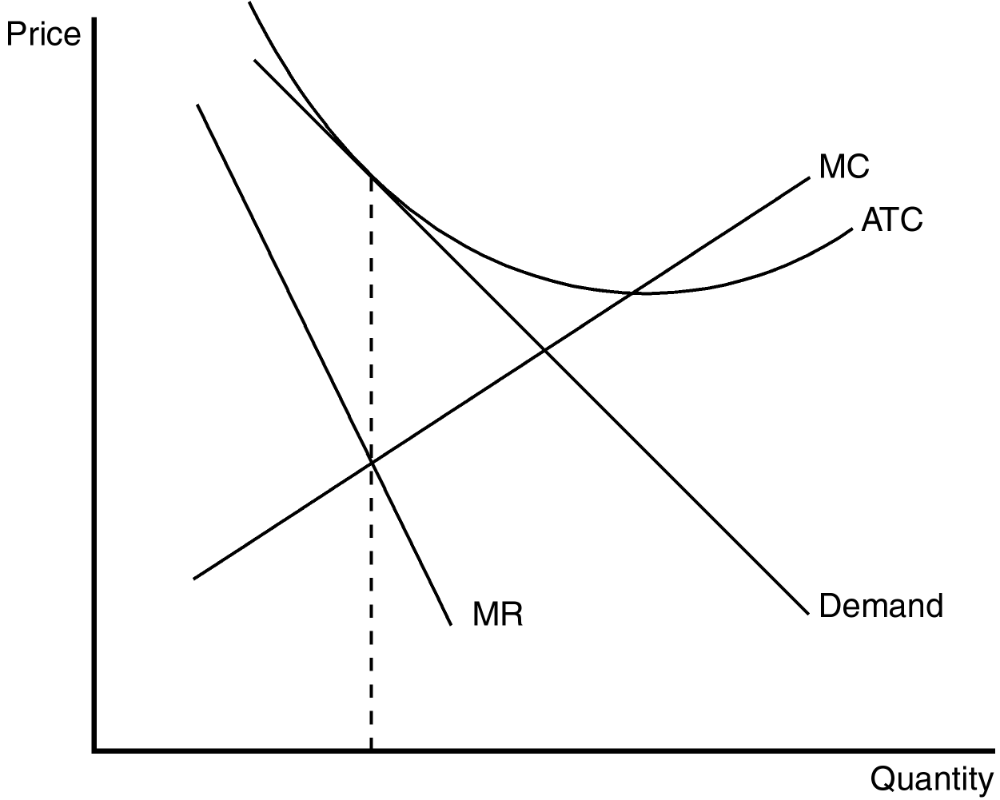

Competitive firms do not face downward-sloping demand. The graph shows the firm choosing a level of production in which the intersection of marginal revenue and marginal cost occurs at an output level where average total cost is decreasing. This profit-maximizing output level is less than the efficient scale (minimum of average total cost) and therefore the firm is said to be operating at excess capacity.
TYPE: S DIFFICULTY: 2 SECTION: 17.1
4. In a small college town, four microbreweries have opened in the last two years. Demonstrate the effect of these new market entrants on demand for incumbent firms (microbreweries) that already served this market. Assume that the local community now places a moratorium on new liquor licenses for microbreweries. How will this moratorium affect the long-run profitability of incumbent firms?
ANSWER:

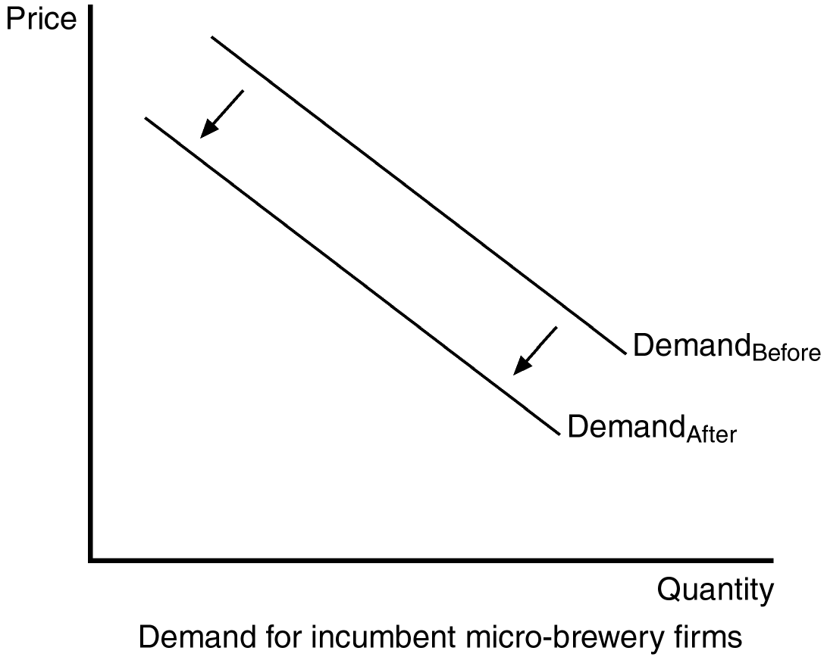

The arrival of a new entrant should be graphically depicted by a leftward shift in the demand curves faced by all incumbent firms. If firms are able to make economic profits, these will be able to be maintained in the long run if new entrants are not allowed.
TYPE: S DIFFICULTY: 2 SECTION: 17.1
5. In many college towns, private independent bookstores typically locate on the periphery of the college campus. However, in some college towns, the University has used political power to restrict private bookstores near campus through community zoning laws. Use your knowledge of markets to predict the price and quality of service difference in the market for college textbooks under these two different market regimes.
ANSWER: In monopoly markets, price will be higher and the quality of service will be lower than in monopolistically competitive markets.
TYPE: S DIFFICULTY: 2 SECTION: 17.1
6. List five goods that are sold in a monopolistically competitive market.
ANSWER: books, CDs, movies, computer games, and piano lessons are some examples.
TYPE: S DIFFICULTY: 1 SECTION: 17.1
7. Why does a typical monopolistically competitive firm face a downward-sloping demand curve?
ANSWER: Because its product is different from those offered by other firms.
TYPE: S DIFFICULTY: 1 SECTION: 17.1
8. What is meant by the term “excess capacity” as it relates to monopolistically competitive firms?
ANSWER: In the long run, monopolistically competitive firms produce a level of output lower than the efficient scale and are therefore said to have excess capacity.
TYPE: S DIFFICULTY: 2 SECTION: 17.1
9. Assume the role of a critic of advertising. Describe the characteristics of advertising that reduce the effectiveness of markets and decrease the social well-being of society.
ANSWER: Advertising manipulates people's tastes and is psychological rather than informational; as a result it creates a desire that might not otherwise exist. Advertising may also impede competition by convincing consumers that products that are identical have significant differences.
TYPE: S DIFFICULTY: 2 SECTION: 17.2
10. Assume the role of a defender of advertising. Describe the characteristics of advertising that enhance the effectiveness of markets and increase the social well-being of society.
ANSWER: advertising provides information to consumers and thus allows consumers to make more informed (and thus better) choices. Advertising fosters competition by making consumers more aware of prices and product characteristics in a market.
TYPE: S DIFFICULTY: 2 SECTION: 17.2
11. Evaluate the following statement: "Advertisements that use celebrity endorsements are devoid of any value and do not enhance the efficient functioning of markets."
ANSWER: Some people argue that celebrity endorsements are a signal of quality. If so, then they relay information and enhance the effective functioning of markets.
TYPE: S DIFFICULTY: 2 SECTION: 17.2
12. Discuss how "brand names" may enhance the efficiency of markets in a less developed country.
ANSWER: Recognizable brand names signal quality products. In the tourist and business services market this signal can be critical at the early stages of development to ensure visitors have a quality experience when other information is unavailable or unreliable.
TYPE: S DIFFICULTY: 2 SECTION: 17.2
13. For many years, Pepsi operated a "taste test" booth at local fairs across the United States. Visitors to the booth would be encouraged to take a blind "taste test" between Pepsi and its primary market competitor, Coke. Pepsi then used the taste test results in advertising Pepsi. What advertising theory does such an approach support? Pepsi no longer uses this as an advertising strategy, but rather, relies on celebrity endorsements and other forms of advertising. What advertising theory do you think now dominates the market between Pepsi and Coke? Explain.
ANSWER: The taste test used the "advertising as information" theory of advertising. Celebrity endorsement is the "advertising as a signal of quality" theory of advertising.
TYPE: S DIFFICULTY: 2 SECTION: 17.2
14. Professional organizations (e.g., American Medical Association and American Bar Association) have been active advocates for regulation to restrict the right of professionals to advertise. Describe what economic incentives might exist for incumbent professionals to restrict advertising.
ANSWER: If advertising increases information about prices and services, then providers of professional services will be required to compete with each other on the basis of price and service. As such, incumbent professionals will be subject to more competitive pressure in the markets they service, and individual profits are likely to fall.
TYPE: S DIFFICULTY: 2 SECTION: 17.2
15. In markets where the government imposes an excise tax on unit sales, it also has a tendency to dabble with restrictions on advertising (i.e., cigarettes, hard liquor). Do potential (or actual) restrictions on advertising in these markets serve the interest of a government that is interested in maximizing its tax revenue from the sale of these products? Explain your answer.
ANSWER: In the case of the examples given, demand is quite inelastic, so restrictions on advertising are not likely to have a large impact on total sales, but may have an impact on the distribution of sales across brand names. As such, government revenue is largely unaffected if the tax is on unit sales.
TYPE: S DIFFICULTY: 3 SECTION: 17.2
16. As developing countries make a transition to market-based economies, one of the first major capital investments is in "Western-quality" hotels. Explain why "brand-name" hotel accommodations are a critical step in attracting foreign investment.
ANSWER: Brand-name hotels are a critical first step to economic development because their recognized signal of quality reduces the barriers of facilitating foreign visitors (and their money).
TYPE: S DIFFICULTY: 2 SECTION: 17.2

